The Bitter End
Fallout 3
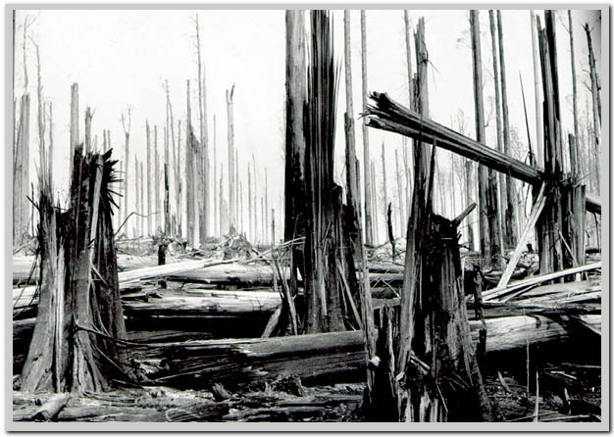
Based on:
CHAN_TheBitterEnd_Fallout3.docx

Table of Contents
Revision Notes 4
Quick Summary 4
Gameplay Overview 5
General Game Flow 5
Major Elements 7
Major Objectives 7
Technical Overview 8
Campaign 8
Mission Location 8
Mission Difficulty 8
Mission Metrics 8
Details 10
Theme/Mood 10
Major Characters/Vehicles 10
Gameplay Mechanics 11
Story 12
Visual References 15
Terrain/Vegetation – Shenandoah Valley 15
Terrain/Vegetation – Vault 231 18
Terrain/Vegetation – Enclave Base 19
Models/Architecture – Shenandoah Valley 19
Models/Architecture – Vault 231 20
Models/Architecture – Enclave Base 20
Textures/Lighting – Shenandoah Valley 21
Textures/Lighting – Vault 231 22
Textures/Lighting – Enclave Base 23
Characters/Vehicles 24
Weapons 31
Pickups 33
Rough Map – Shenandoah Valley 34
Rough Map – Vault 231 35
Rough Map – Enclave Base 36

The Bitter End
Fallout 3
Document Date 11/12/09

Revision Notes
11/12/09 – Adapted Level Abstract
11/09/09 - Initial version of document

Quick Summary
The Lone Wanderer finds a very small, secluded Vault located in the Shenandoah Valley. At the vault, the Wanderer meets a family—consisting of Stan Gilbert, his wife Astrid Gilbert and their young daughter Anna—who endure attacks by ghouls and wildlife. Eventually The Lone Wanderer investigates to reveal that the family is unwittingly involved in a new Vault experiment—titled Project Cohesion–conducted by an Enclave scientist. The Lone Wanderer must deal with the Enclave faction before making a decision on the ultimate fate of the Gilbert family. The Bitter End is a single-player, first/third-person perspective campaign that takes place after the Lone Wanderer leaves Vault 101 and prior to the end of the main storyline.

Gameplay Overview

General Game Flow
After exiting hidden subway tunnel, player starts campaign by accepting quest from Stan Gilbert, husband to Astrid Gilbert and father to Anna Gilbert. Quest requires player to investigate three areas.
  - Player travels to Vault 231, where the player finds a sealed door.
    - Players use Lock picking skill to open door to medical cache.
  - Player travels to the Wildlife Zone, where the player finds a radio tower.
    - Player analyzes the tower through Science skill to hear a strange frequency noise.
  - Player travels to the Ghoul Zone, where the player finds and speaks to Lark, the only non-Feral ghoul in the Ghoul Zone.
- After investigating these three areas and returning to the Gilbert family, a squad of three Talon Company mercs attack.
  - Sidequest: Anna Gilbert gives player a key to enter the main area in Vault 231. Player finds Stan’s Laser Rifle, a quest item that reminds Stan of his past life as an Enclave soldier.
- Player revisits Lark and tells about the Talon Company and the Radio Tower. Lark gives player a sensor module/key that allows player to open a hidden entrance in the Wildlife Zone. The entrance leads to the Enclave base.
- After fighting through more Talon Mercs, player confronts Enclave scientist Millard Karstens, who reveals the nature of the Enclave experiment and pleads the Player to allow it to continue. The player makes one of three dialogue choices:
  - Agree to allow the experiment to continue. After this, the player cannot tell the Gilberts about their situation. Lark confronts the player about this decision outside of the Enclave base. The campaign concludes.
  - Refuse to allow the experiment to continue. Karstens attacks you.
  - Confront Karstens about the Gilberts’ background (selectable if sidequest completed). Karstens reveals the backgrounds of all three members of the Gilbert family before attacking the player.
- If players choose choice 2 or 3, the player returns to the Gilbert family to defend them against an assault staged by Talon Mercenaries.
- Afterwards the player talks to Stan Gilbert and must make one of four choices in dialogue:
  - Lie to Stan. The player receives no Karma ramifications and the Gilberts live a happy, threat-free, ignorant existence.
  - Tell the truth to Stan and convince him to break up the family. The three Gilbert family members part ways and the player never sees them again. The player loses Karma.
  - Tell the truth to Stan and successfully convince him to stay together clears a Speech, Intelligence or Perception test in dialogue.
  - Tell the full truth to the Gilberts (if sidequest completed). Although shocked, Stan’s remembrances of his past allow him to cope with the news better. The Gilberts decide to stay together as a family. The player earns Karma.

Major Elements
- Introduces players to basic mission taking and completion.
- Introduces players to branching quest lines.
  - The successful completion of a side quest allows players a different ending for the campaign.
- Morality-based and conspiracy-shrouded storyline (hook)
- Meeting Lark and finding out more about the Feral Ghouls (major story beat)
- Locating Lark on cliff overlooking the entirety of the Shenandoah Valley (wow moment).
- Finding central Vault area (sidequest wow moment)
- Finding Stan’s Laser Rifle and helping him remember his past (sidequest story beat)
- Finding Enclave mini-base (wow moment)
- Confronting Millard Karstens and finding out more about the Enclave experiment (major story beat).
- Final defensive battle against Talon Company mercs (wow moment).

Major Objectives
- Avoid dying from enemy attacks
  - The player must avoid or block melee attacks (blocking inherent to game).
  - All enemies in outdoor area
- Defend Gilbert family from enemy attacks.
- Find out about the reasons for the Gilbert family’s situation.

Technical Overview

Campaign
- The main story involves The Lone Wanderer helping the Gilbert family by protecting their home and bringing them peace.
- A side mission given by Anna Gilbert involves finding out more about the backgrounds of her father Stan. The side mission affects the ultimate outcome of the main story.

Mission Location
- Setting: Shenandoah Valley, Virginia, located miles west of Washington DC.
- Time: Variable (24 hours a day possible).
- Season: Variable (Post-nuclear apocalypse/Season-less)
- Weather: No weather patterns save for the daytime/nighttime pattern of the Wastelands. Clear-to-Cloudy skies (variable).

Mission Difficulty
- Difficulties rate upon a scale of 5, relative to the player’s level due to Fallout 3’s inherent difficulty scaling.
- Act I: ~2. The campaign begins with exploration and simple combat against isolated enemies.
- Act II: ~1 to 3. The middle of the campaign requires some skill usage and multi-target combat. However, players encounter minimal combat and more exploration/dialog over the course of the late/middle of the game.
- Act III: ~2 to 4+. The difficulty of Act III depends entirely on player choice. If the player helps the Gilbert family, the climax of the game includes a more difficult defensive fight against multiple targets. If the player sides with Millard Karstens and allows the experiment to continue, the quest ends without a climactic battle.

Mission Metrics
- Average Play Time: ~1-2 hours
- Max Length/Area: The campaign encompasses ~576 x 576 square feet (3 x 3 outdoor Fallout tiles) along a diamond shaped mountain valley, including surrounding mountains. Additionally, the campaign includes two interiors: a vault area and an Enclave base interior (total: 100 feet of ~4-foot wide corridors plus ~4 small rooms).
- Critical Path Length: ~576 x 576 square feet. The player must traverse the entire length of the map, including interiors. Sometimes, players must travel over terrain two or three times. However, the inclusion of quick travel areas allows players to move through the campaign without traversing the entire length.
- Max New Characters: 18+, The Lone Wanderer (main character), Stan Gilbert (ally), Astrid Gilbert (ally), Anna Gilbert (ally), Millard Karstens (Enclave scientist), four squads of three Talon Company mercenaries, as well as numerous Feral Ghouls, Rabid Dogs and four Yao Guai.
- Max New Vehicles: None, except for two burnt out cars indicating a weapons/ammo cache.
- Max New Weapons: Variable. Talon Company characters carry random weapons. Vault 231 contains one special weapon: Stan’s Laser Rifle, a quest item that functions as a normal Laser Rifle.
- Visual Themes: 3—Inside Vault 231, outdoors in the valley itself, and within the Enclave base of operations cave.

Details

Theme/Mood
The level centers on the Shenandoah Valley area of western Virginia. The game play area

Major Characters/Vehicles
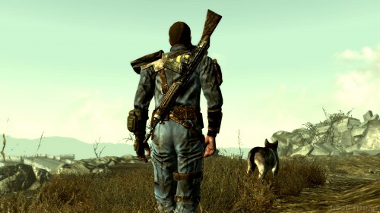
- The Lone Wanderer – Standard player character from Fallout 3. Race/Age/Features/Skills/Equipment determined by player.
- Stan Gilbert – Ally to the main player and original quest-giver, Stanley maintains the Gilbert’s small farm in the Shenandoah Valley. The Enclave brainwashed Stan—along with Astrid and Anna—as a test subject. Before Project Cohesion, Stan served as an Enclave soldier. Stan is an adult male custom model of medium-tall height and Hispanic ethnicity (black hair, clean-shaven. He wears a Merc Adventurer outfit and carries a 10mm Submachine Gun. Stan can equip a named Laser Rifle found in Vault 231.
- Astrid Gilbert- Ally to the main player. Astrid believes she settled down with Stan and gave birth to Anna over a decade ago. In reality, Astrid served as a raider prior to Project Cohesion. The player may barter with Astrid. Astrid is an adult female custom model of medium height and Caucasian ethnicity (chin-length blonde hair). She wears a Merc Veteran outfit and carries a Combat Shotgun. Her trade inventory includes food and some ammunition.
- Anna Gilbert- Ally to the main player. Anna is the young daughter of Stan and Astrid, although not by blood relation. Anna offers the player a side quest to investigate her father’s background. Anna is a teenaged female custom model of short stature and Caucasian ethnicity (chin-length black hair). Anna wears the girl’s Athlete of the Waste outfit and carries a 10mm Pistol.
- Lark – Ally to the main player. Lark is the only non-Feral ghoul in the Ghoul Zone of the outdoor map. Lark knows about the Gilbert family and seeks to protect them by sealing and guarding the entrance of a Feral Ghoul-packed cave in the Ghoul Zone. Lark refuses to mention his past, although his familiarity with the Talon Company suggests that he previously wandered the DC Wastelands. Lark is an adult male ghoul model of medium-tall height. Wears Merc Grunt outfit and carries a Chinese Assault Rifle.
- Millard Karstens – Neutral/Potential Enemy to the main player. Karstens is the Enclave scientist in charge of Project Cohesion, the experiment that brainwashed the Gilbert family. Karstens is an adult-male custom model at medium-tall height and Caucasian ethnicity (brown hair, bearded). Karstens wears a Lab Technician coat and carries a Laser Rifle.
- Enemies: Members of the Talon Company (stock models), Feral Ghouls (stock models), rabid dogs and Yao Guai (stock models)
- Others: None

Gameplay Mechanics
- Prerequisite skills:
  - Basic first-person shooter knowledge.
    - Moving/Strafing
    - Turning/Aiming
    - Jumping
    - Ducking/Sneaking
    - Utilizing Cover
    - Melee attacks
    - Shooting attacks
- Learned skills:
  - Basic understanding of Fallout 3 combat fundamentals
    - V.A.T.S. system
  - Basic understanding of Fallout 3 quest fundamentals
    - Quest taking/giving
    - World Map use
    - Inventory use
  - S.P.E.C.I.A.L. skills as determined by the player (repair, lockpicking, etc.)

Story
- The story begins with the Lone Wanderer hearing rumors of an isolated Vault—numbered 231—located in the Shenandoah Valley, accessible via a subway tunnel on an isolated track.

- Upon arriving at the Vault, the Lone Wanderer finds a small settlement consisting of a single family of three: Stan Gilbert, his wife Astrid Gilbert, and their daughter Anna. The family lived in the valley for years in seclusion and peace, but now endures multiple attacks from ghouls and wildlife. Stan asks the Wanderer to investigate the surrounding areas.

- After trekking across the valley basin, Wanderer finds several clues about the Gilberts’ situation, including meeting Lark, the only non-Feral Ghoul in the valley who informs the player that he knows about the Gilberts’ situation and that he is attempting to stem the tide of Feral Ghouls from overwhelming the family.

- After accomplishing the three tasks, the Wanderer returns to the Gilberts. However, Talon Company mercenaries attack the family and the Wanderer. The arrival of the mercs bewilders the Gilberts, who ask the Wanderer to ask for help from Lark.

  - Anna Gilbert approaches the Wanderer asking for help about Stan. Anna feels her father becoming more despondent and irregular. She provides the Lone Wanderer with a keepsake—a key card, that gives access to the central area of Vault 231. Inside, the Wanderer finds a nearly pristine vault. In one room, the Wanderer finds Stan’s Laser Rifle, a memento from Stan’s past as an Enclave soldier, detailed on a computer full of Stan’s memoirs. When the Wanderer returns the rifle to Stan, Stan feels nostalgic and equips the rifle.

- Lark mentions the irregularities around the strange radio tower in the Wildlife Zone. He gives you a sensor module to open the Enclave base, a door hidden into the mountain.

- After clearing the base of Talon Mercenaries, the Wanderer confronts Millard Karstens, an Enclave scientist and head of an experiment called Project Cohesion. The Project entails afflicting a cohesive family with various problems, difficulties and dangers to see how the family lasts under duress.

- The Lone Wanderer must make a choice on how to handle Karstens:

  - Agree to let the experiment continue, which closes off the rest of the quest to the Wanderer. Upon leaving the Enclave base, Lark angrily refuses to speak to the Wanderer again. The quest ends here.
  - Kill Karstens. If the Wanderer does this, Karstens sends a full contingent of Talon Mercenaries to attack the Gilberts.
    - Karstens reveals the full extent of Project Cohesion—including the backgrounds of each family members—if the Wanderer performed the task that Anna Gilbert asked him to do. After this, Karstens attacks the Wanderer.

- The Wanderer then hurries back to the Gilberts to help defend them against a contingent of Talon Company mercenaries. Lark also shows up to help.

- After the climactic battle, Stan Gilbert demands to know the truth from the Wanderer. The Wanderer handles this conversation in

  - Lie to Stan about the truth. The Gilberts accept the Wanderer’s explanation and live peacefully in the valley, ignorant of the Enclave and Project Cohesion.
  - Tell the truth to Stan and convince him to break up the family. The three Gilbert family members part ways. The Wanderer never sees Stan or Astrid again. Lark takes Anna under his wing and refuses to let the Wanderer see her again.
  - Tell the truth to Stan and successfully convince him to stay together. The family struggles with the truth, but decide to attempt to stay together. Lark pledges to help the Gilberts in any way they can, but the prospect of them making it seems shaky.
  - Tell the full truth to the Gilberts (if sidequest completed). Although shocked, Stan’s remembrances of his past allow him to cope with the news better. The Gilberts decide to stay together as a family and live peacefully in the valley.

Visual References

Terrain/Vegetation – Shenandoah Valley
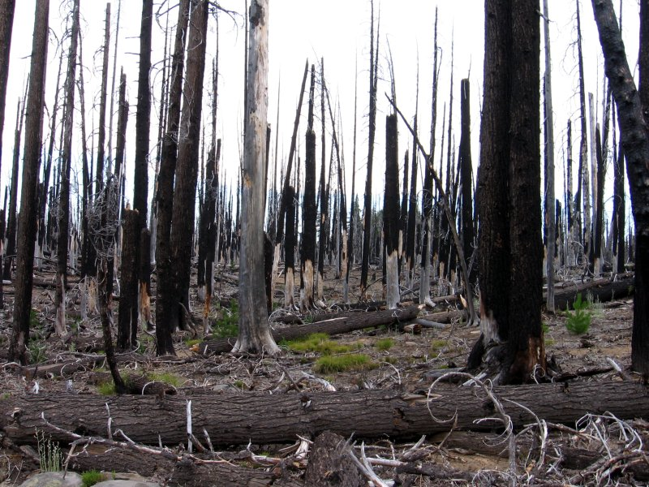
Burnt Forest
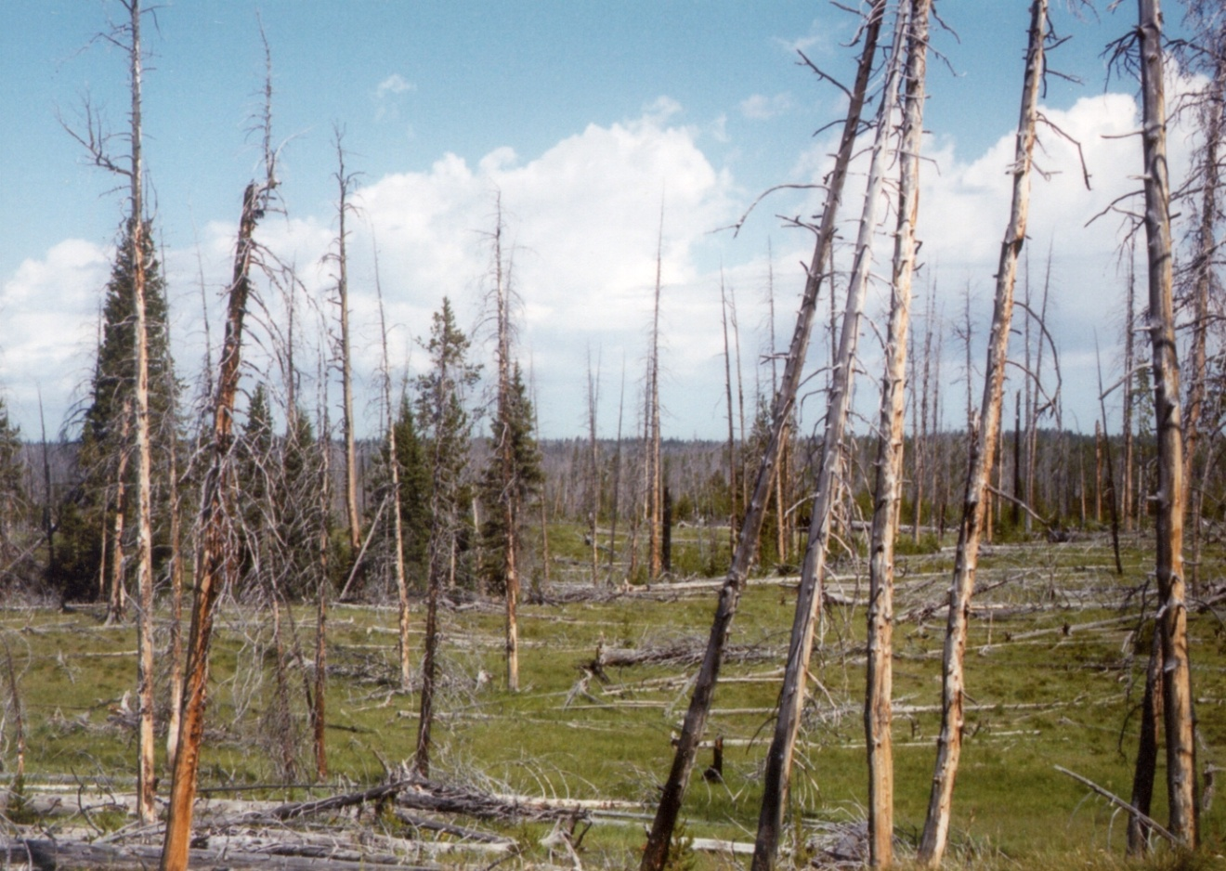
Burnt Forest 2

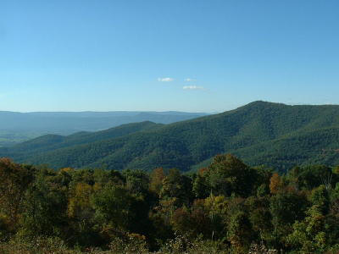
Shenandoah Valley hills

Terrain/Vegetation – Vault 231
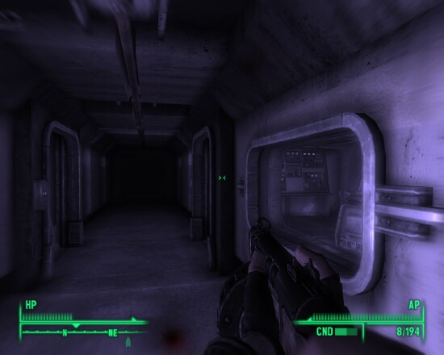
Vault Interior
Vault Interior 2

Terrain/Vegetation – Enclave Base
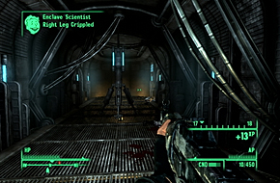
Enclave Base

Models/Architecture – Shenandoah Valley
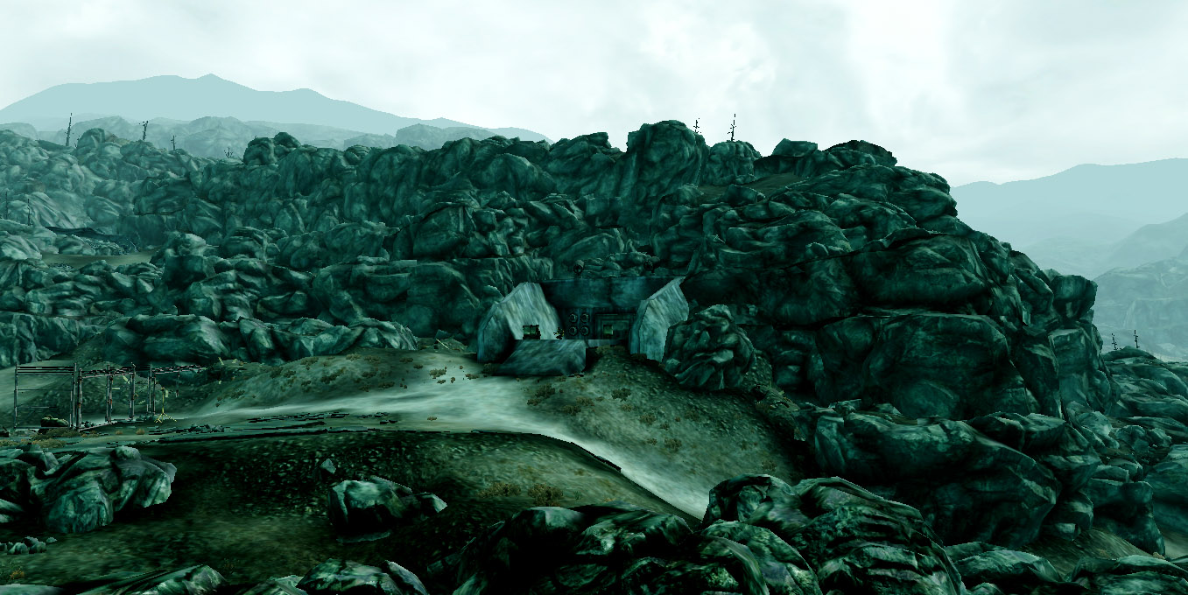
Barren, Rocky Hills

Models/Architecture – Vault 231
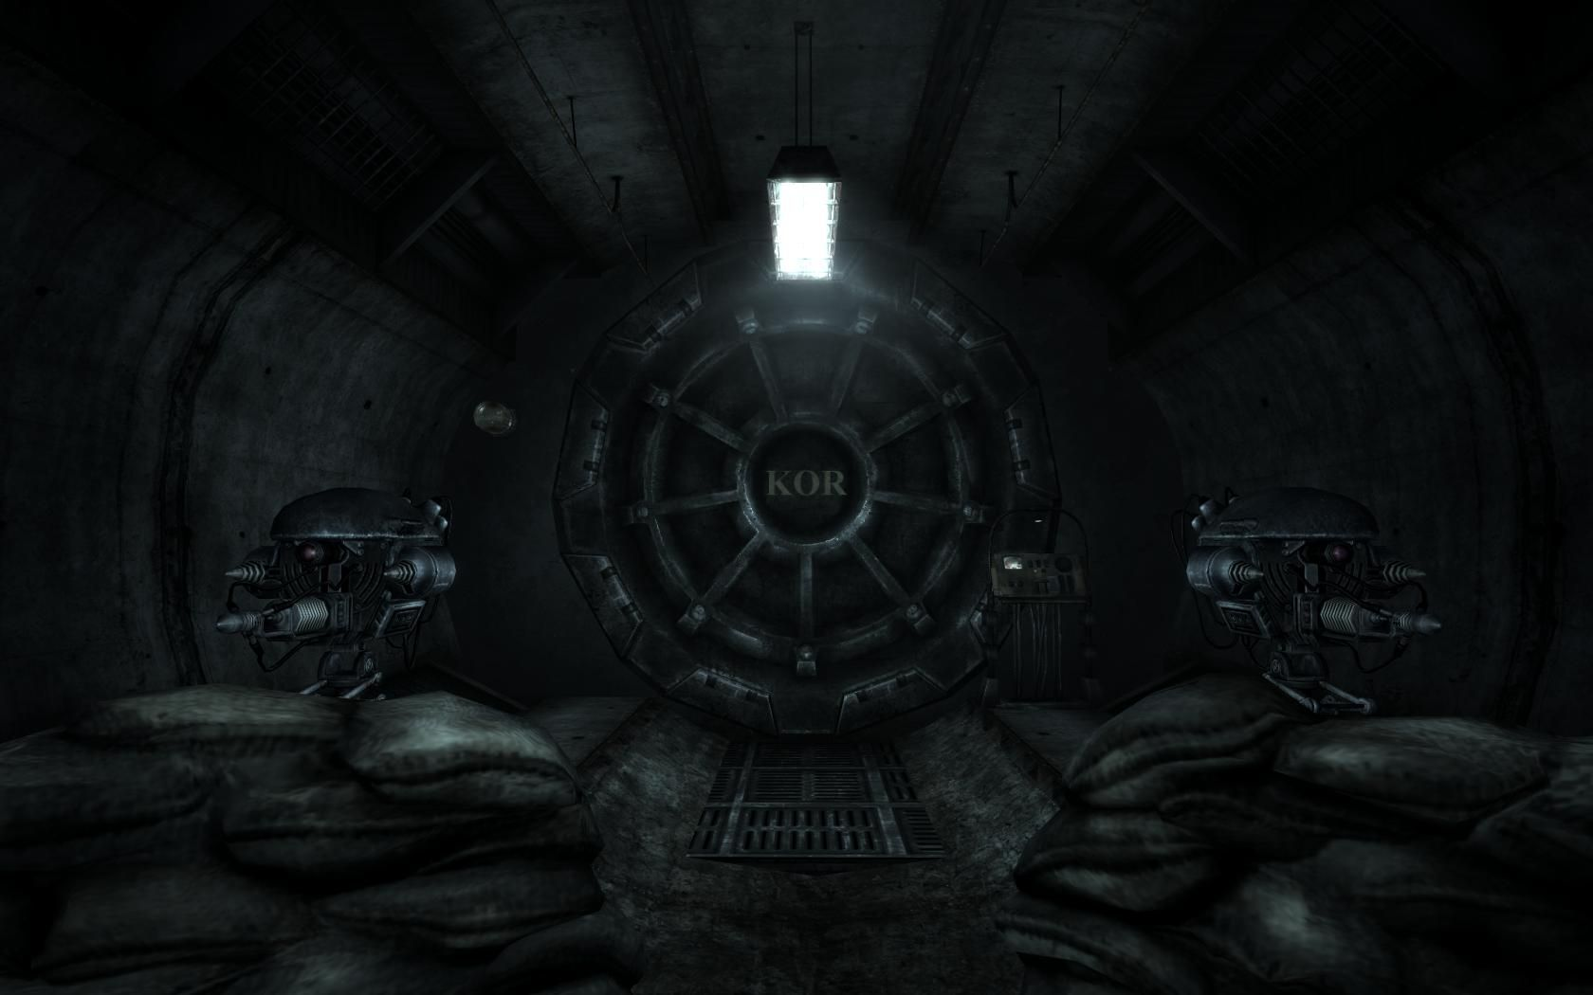
Vault Interior/Door

Models/Architecture – Enclave Base
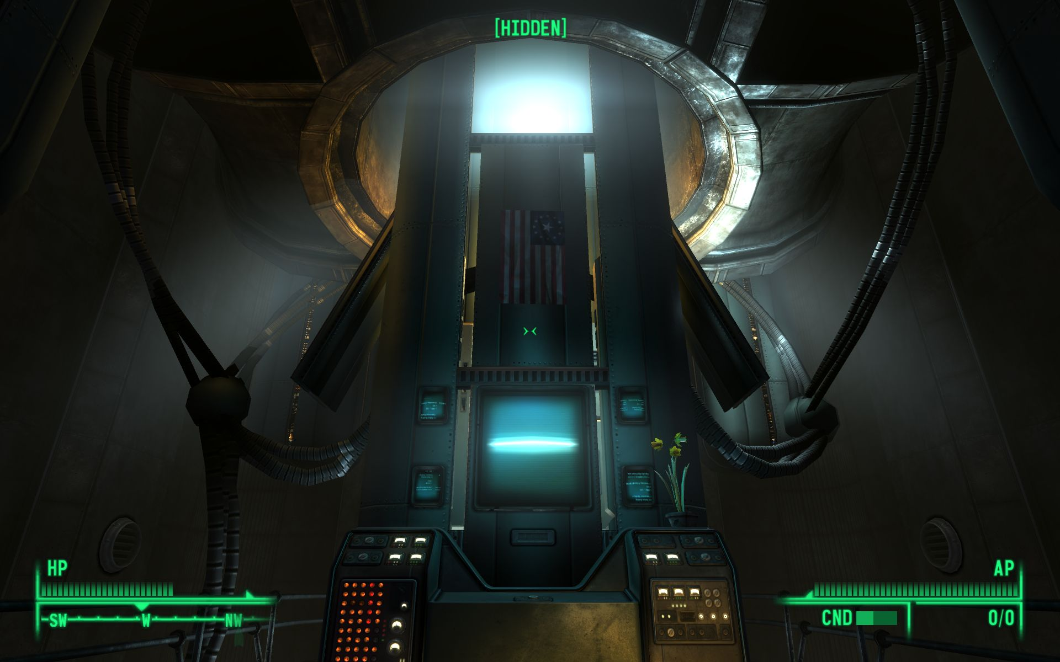
Center of Enclave Base

Textures/Lighting – Shenandoah Valley
Burnt Wood
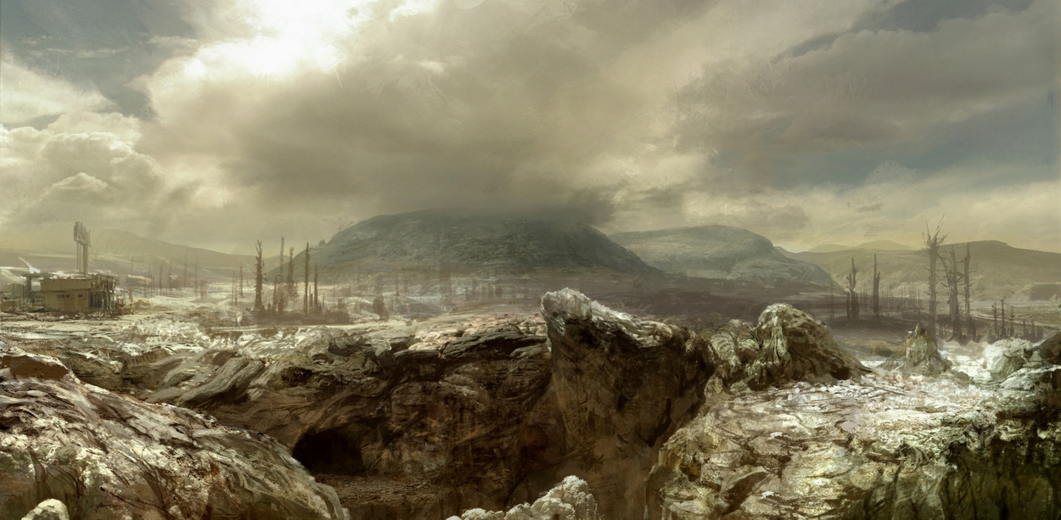
Wasteland Terrain

Textures/Lighting – Vault 231
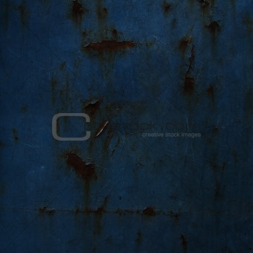
Dark, blued metal walls

Textures/Lighting – Enclave Base
Dark metal walls

Characters/Vehicles
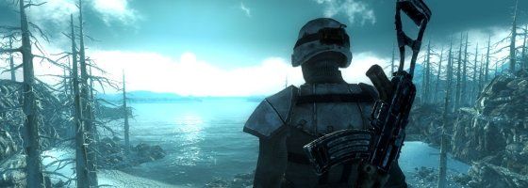
The Lone Wanderer (Player)
Stan Gilbert
Astrid Gilbert

Anna Gilbert
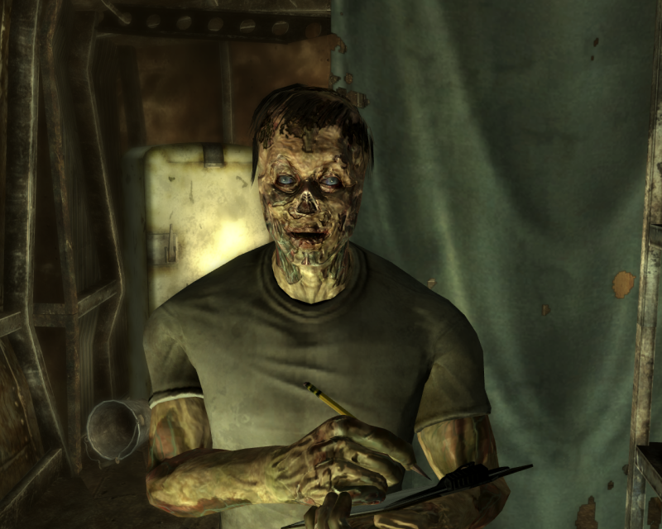
Lark
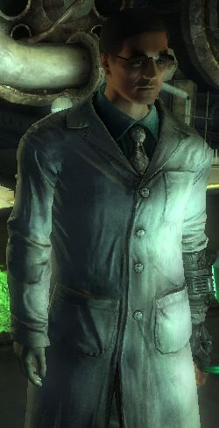
Millard Karstens
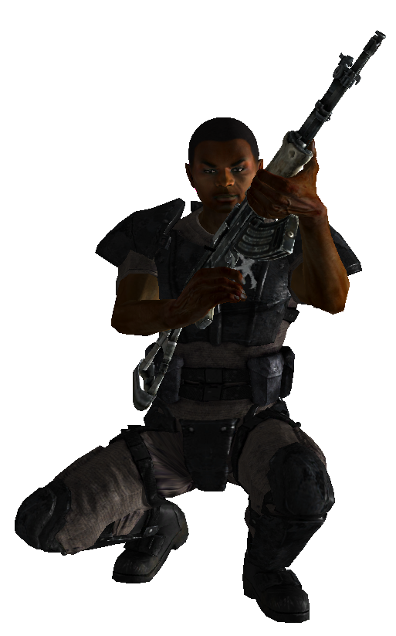
Talon Company Mercenaries
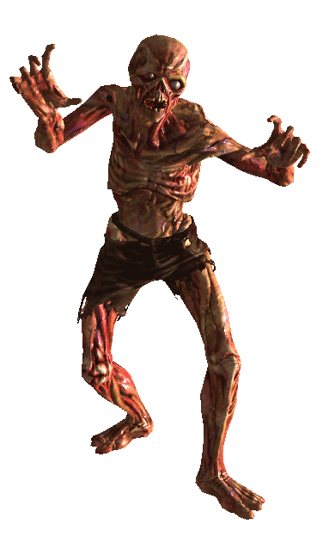
Feral Ghouls
Rabid Dogs
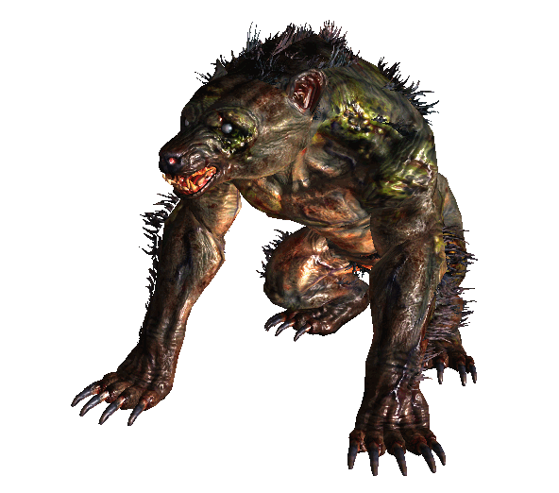
Yao Guai

Weapons
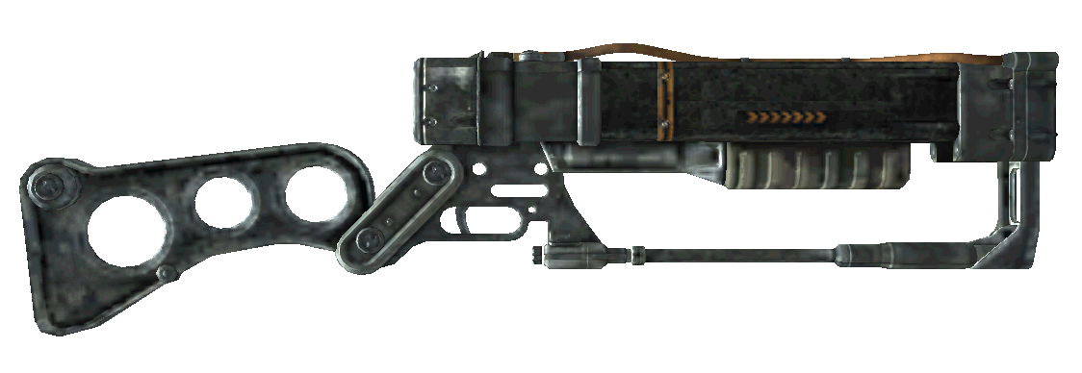
Laser Rifle
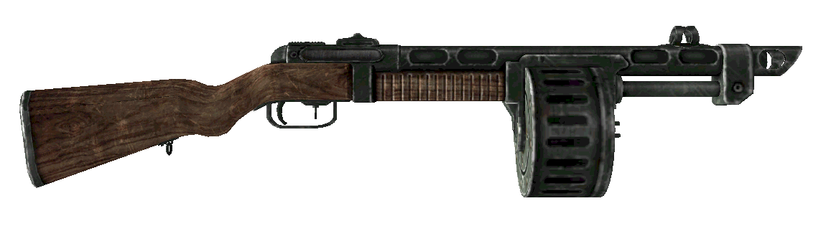
Combat Shotgun
10mm Submachine Gun
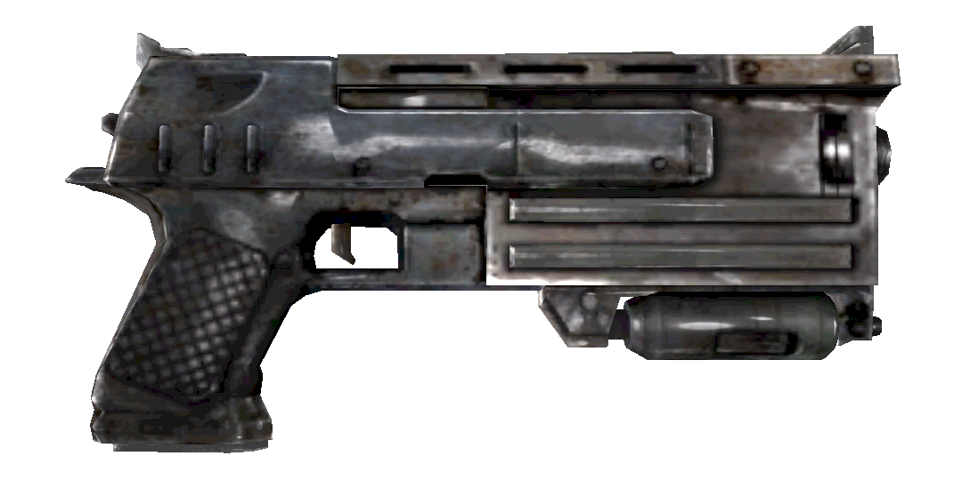
10mm Pistol
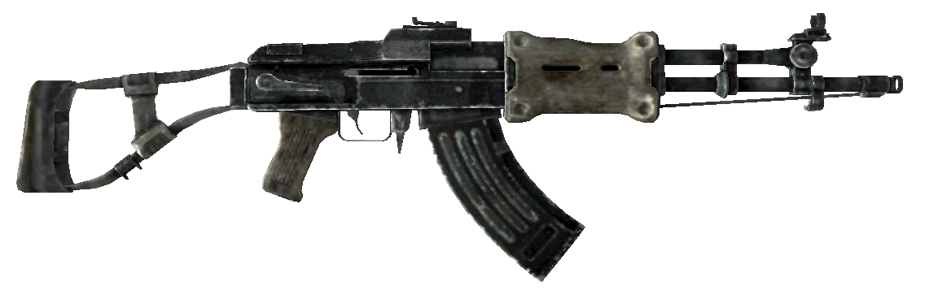
Chinese Assault Rifle

Pickups
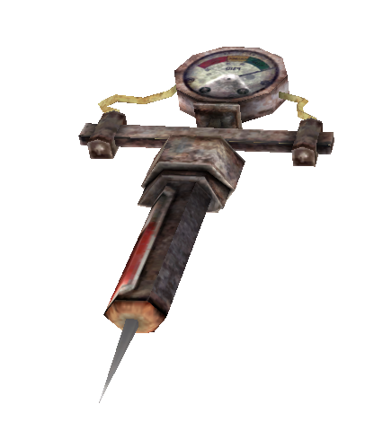
Stimpack
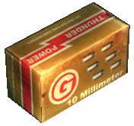
Various Ammunition

Rough Map – Shenandoah Valley
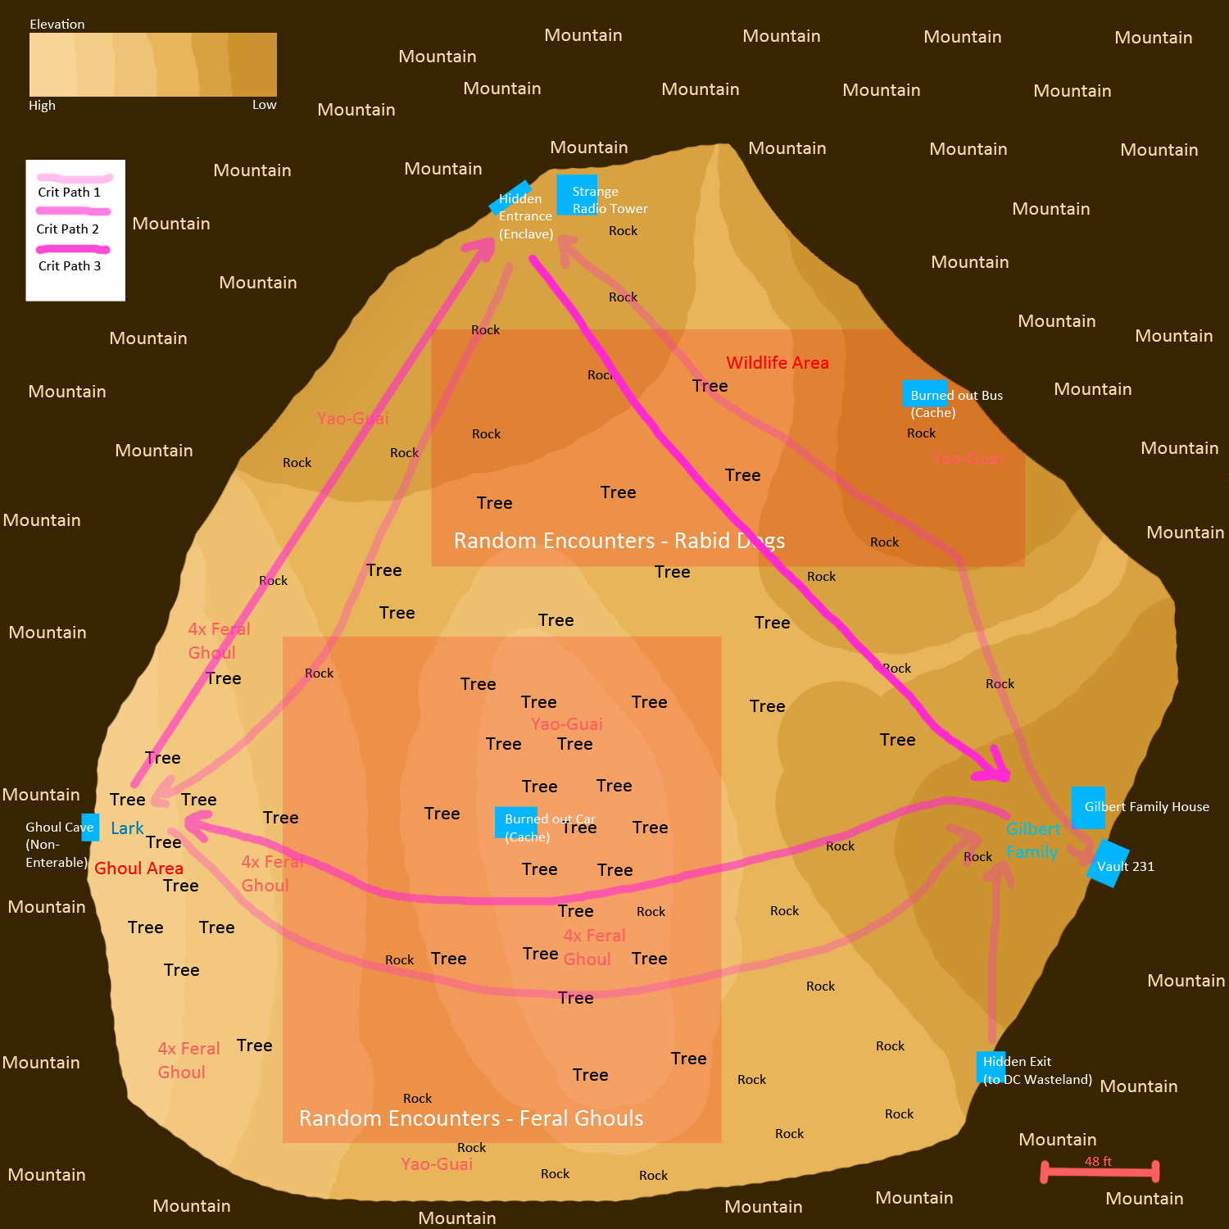

Rough Map – Vault 231
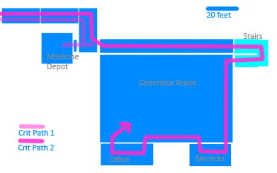

Rough Map – Enclave Base
