Infinity
Unreal Tournament 3
Document Date: 02/12/10
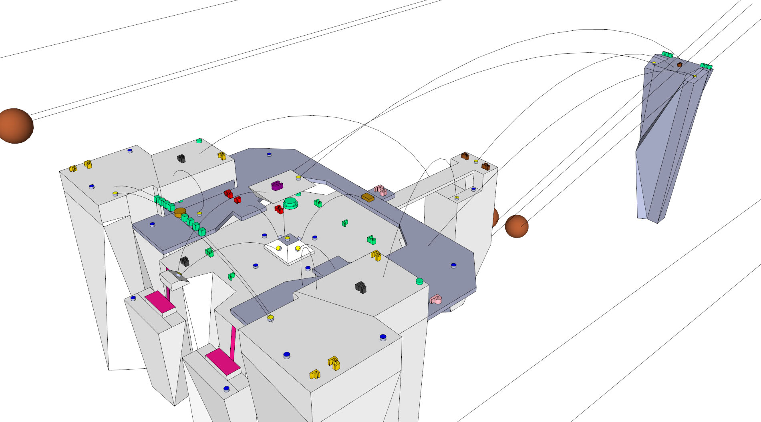

Designer: Wade-Hahn Chan
Intended Level Delivery Date: 03/05/2010
Table of Contents
Document Revisions Table 3
List of Figures 4
Quick Summary 5
Gameplay Overview 6
General Game Flow 7
Major Elements 12
Major Objectives 13
Environmental Hazards 13
Technical Overview 14
Mission Location 14
Gametype(s) 14
Items/Powerups 14
Difficulty 15
Mission Metrics 15
Level Details 16
Theme/Mood 16
Special Character/Vehicle Needs 16
Gameplay Mechanics 16
Backstory/History 16
Visual References 18
Terrain/Vegetation 18
Models/Architecture 25
Textures/Lighting 27
Characters/Vehicles 30
Maps 31
Legend 31

Document Revisions Table
VERSION | DESCRIPTION | UPDATED BY | DATE
1.0 | Adapted Abstract to GDD | Feb. 11, 2010

List of Figures
Figure 1: Red paths indicate spawned critical path points, Yellow includes additional points, Open nature of map allows for almost complete flow from any direction 6
Figure 2: Wormhole 18
Figure 3: Ruined building 19
Figure 4: Destroyed brick wall static mesh 20
Figure 5: Broken Reinforced concrete 20
Figure 6: Broken concrete 21
Figure 7: Metal cargo container 21
Figure 8: Standing rubble pile 22
Figure 9: Human trash 22
Figure 10: Ruined skyscraper 23
Figure 11: Concrete, building materials, junk 24
Figure 12: Floating concrete rubble 25
Figure 13: Ruined buildings, rubble 26
Figure 14: Broken reinforced concrete pillar 27
Figure 15: Broken concrete texture detail 28
Figure 16: Human building corner 28
Figure 17: Human outdoor lamp 29
Figure 18: Aurora Borealis. The wormhole consists of multi-hued colors. 29
Figure 19: Key/Legend 31
Figure 20: Overall Flow (details in Gameplay Overview section) 31
Figure 21: Overall Isometric View (First View) 32
Figure 22: Key/Legend 32
Figure 23: Overall Isometric View (Second View) 33
Figure 24: Key/Legend 33
Figure 25: Overview of main map area (note floating rubble on either side) 34
Figure 26: Key/Legend 34
Figure 27: Overview of sniper roost (lower left indicates flying rubble obstacles) 35
Figure 28: Key/Legend 35
Figure 29: Rear Elevators and arcing jump pad detail (Elevators follow magenta path) 36
Figure 30: Key/Legend 36
Figure 31: UDamage platform to Sniper roost jump pad (Arc has less chance of hitting flying debris, but players take damage) 37
Figure 32: Key/Legend 37

Quick Summary
- Tension, instability and exposure make a great deathmatch experience.
- Infinity is a multiplayer deathmatch map that takes place within the Unreal Tournament 3 first-person shooter. In it, players fight in a dangerous wormhole atop broken, floating human buildings strung together by wire and nearly broken columns. The level features an open environment with little cover and many opportunities for players to kill each other. The fighting occurs on three different floors, with a sniper roost located far away from the main map. Players traverse the level by using numerous jump pads, making for furious, high-flying deathmatch action. Visually, the map takes place a top floating, ruined buildings while rubble and rocks fly around the playing area, crashing into each other. The level supports sixteen players.

Gameplay Overview
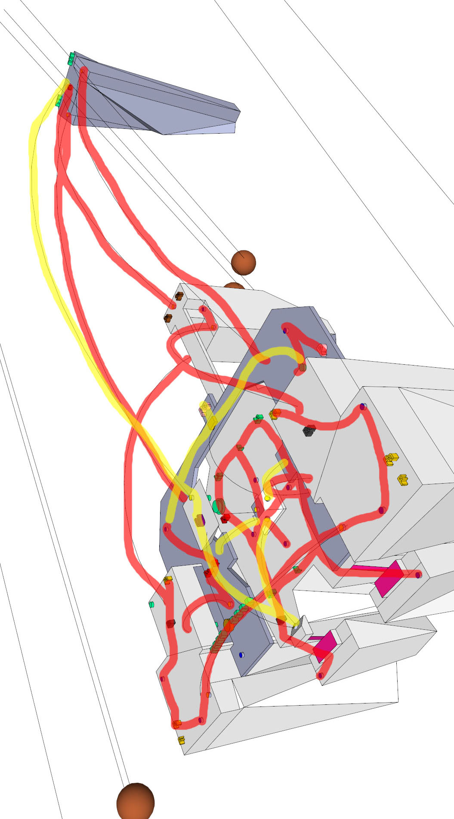
Figure 1: Red paths indicate spawned critical path points, Yellow includes additional points, Open nature of map allows for almost complete flow from any direction

General Game Flow
The level consists of symmetrical (along the length) platforms that give players an arena-style experience.
The map’s flow allows players numerous choices in the map, which gives a visceral deathmatch experience. What follows is an example of how the flow works for a given player spawn.
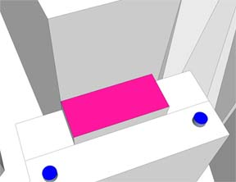
The Player spawns on the lowest point of the map, where an elevator sits in front of him.
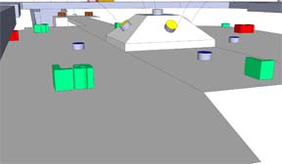
The takes the elevator up and finds numerous players fighting each other. In front of the player sits a tree of jump pads. He moves forward to collect link gun ammo and to the immediate right to collect a Link gun.
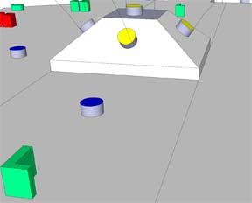
Dodging Rockets coming from above, the player kills an enemy wielding another Link Gun. Deciding that he too wants a Rocket Launcher, he takes the right hand jump pad on the tree.
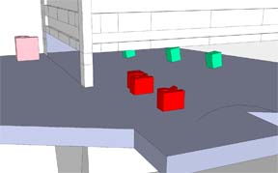
He grabs the Rocket Launcher, but someone else already took the ammo pack. He swings into the covered area, kills a Flak Gun-wielding enemy, grabs the three health vials and takes the Portal.
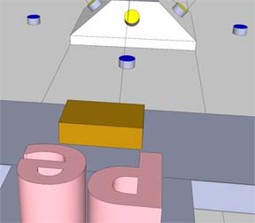
He pops out on the middle of the bridge and collects leg armor. Although exposed, he fires of several rockets at enemies below and earns two kills. He turns around to drop down on to the bridge connecting to the jump pad leading to the sniper roost.
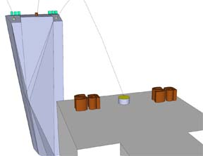
He runs down the bridge and grabs two Sniper Rifle ammo packs before taking the jump pad over the chasm to the Sniper Roost. An enemy, standing in the roost, attempts to snipe the player in mid-air but misses. The player charges up three rockets and kills the enemy sniper.
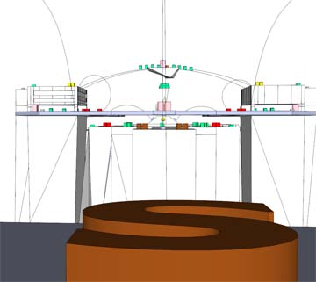
The player grabs six health vials from the back of the sniper roost. He also picks up the Sniper Rifle. The roost grants him excellent views of the entire map, although rubble sometimes flies by and fouls his shots. He snipes two people before taking the right hand jump pad back to the main structure. Rockets strike the sniper roost as he leaves.

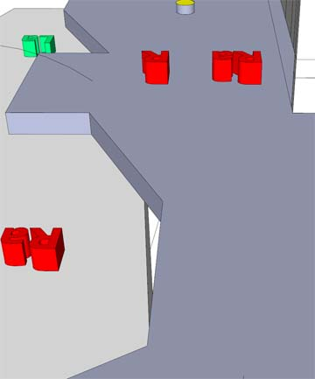
The lands and rushes forward for more rocket ammo. The health vials in the covered area are gone. He decides not to take the Portal and instead wants a better vantage point, as well as a Flak Gun for close combat options. He takes the jump pad that sends him to one of the third floor platforms.
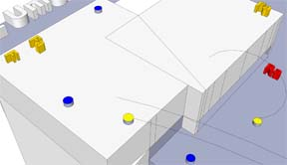
Above, a fierce fight takes place between two opponents. Charging up rockets, the player kills both of them with one shot. He runs forward to grab the Flak Gun, equips it, and then runs towards the jump pad connecting the other third floor platform.
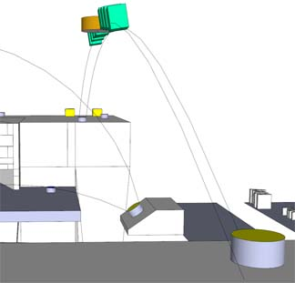
The player jumps in midair, but spies another enemy coming the other way on the other jump pad! The enemy hit the pad first, so the player just misses the Chest Armor suspended in midair. The two clash against each other, but the enemy fires first. The player dies from Flak Gun fire.

Major Elements
- The map provides players fast-paced, brutal combat across a classic deathmatch design.
  - Open areas and little cover
  - Close combat options (Rocket Launchers and Flak Guns) as well as long-range options (Sniper Rifle)
  - Power-Ups that lead players to further combat
  - A central “jump pad tree” containing jump pads that send players to five different directions
  - Additional high-flying jump pads that provide speedy movement to all areas of the map
- Major movement structures include:
  - Multiple jump pads that provide speedy movement and multiple targets of opportunity from all angles
  - Elevators, which provide some player spawns with un-camp-able spawn locations
- The map features several wow moments in terms of visuals:
  - A wormhole that features shifting winds and tunnel routs
  - Debris that dips in and out of the wind and smashes into each other, the buildings and sometimes airborne players

Major Objectives
Players achieve victory on the map by earning 20 kills. Alternately, players win by earning the most kills within the map time limit (as determined by server).

Environmental Hazards
Infinity takes places within a wormhole. The platforms float precariously, suspended in midair. Players perish if they fall off the main platforms.

Technical Overview

Mission Location
- Setting – On human buildings trapped in a wormhole and lost in time and space
- Time of Day – N/A, the wormhole supplies no time. Light comes from multiple directions in the wormhole, creating diffuse, multi-faceted shadowing.
- Season – N/A, the wormhole supplies no season. The inside of the wormhole provides ample lighting.
- Weather – N/A, the wormhole supplies no weather, although players see various pieces of destroyed buildings fly through the air in the background.

Gametype
- Deathmatch
  - Min Players: 8
  - Ideal Players: 16
  - Max Players: 16

Items/Power-Ups
- The map includes seven total weapon spawns. For each weapon spawn, the map includes two ammo packs for a total of ten ammo packs. Additionally, the map includes four Enforcer ammo packs.
  - Default equipment load out on spawn:
    - Impact Hammer
    - Dual Enforcers
  - Weapons present on the level:
    - One Sniper Rifle – Located on a small platform separate from the bulk of the map, players only access the sniper roost through a long-distance jump platform connected by bridge or through a jump pad at the top UDamage platform. Taking the UDamage platform to the sniper roost incurs damage on the player. The rifle’s position allows full view of the entire map, due to the main level area’s flatness and the distance. However, flying rubble and debris sometimes obstructs the sniper’s view. Additional, debris may collide with airborne players, sending those players to their doom through falling.
    - Two Rocket Launchers – On the central platform sits Rocket Launchers—near the bulk of the spawns, a portal and a jump pad. Rocket Launchers provide a wide variety of combat options for the player spawning: mid-air firing, firing into the lower level, and enough time to load extra rockets into their shots.
    - Two Flak Guns – Sitting at the top two levels of the map, the Flak Gun gives players the best close combat option on the map. Although the map takes up a lot of space, the multiple levels offer enough situations to
    - Two Link Guns – Two Link Guns sit on the lower platform near the tree of jump pads. Link Guns give players a mid-range option to combat against the Rocket Launcher and Flak Gun equipped opponents.
- The map also contains two armor pieces:
  - One Chest Armor – Located suspended mid-air between two jump pads linking the upper platforms. Taking either jump pad allows players to collect the armor. The armor sets up potential mid-air clashes.
  - One Leg Armor – Located on a narrow bridge connecting the two middle-tier platforms, players access the Leg Armor easily (because all portals send players to it), although exposed on all sides.
- Players find a total of 300 health on the map:
  - One Health Keg: Located straight above the top most jump pad in the tree, the Health Keg gives the biggest boost (100 health) to players, but at the expense of being in an extremely exposed location.
  - Four Medium Health Packs: The level contains four medium health packs:
    - Two on the bottom floor, on the edge closest to the sniper roost.
    - Two on the upper floor, on the edge closest to the sniper roost.
  - Twenty Health Vials:
    - Eight vials next to the Chest Armor, floating in mid-air between the two upper platforms (four on either side).
    - Six vials on the sniper platform, two on either side near the two jump pads leading back to the main platform.
    - Six vials on the lower platform, on either of the jump pad tree on either side.
- Finally, the map contains one power up:
  - UDamage located on a tiny platform high above the map and nearly inaccessible by enemy fire. Next to a portal and only reachable through a double jump pad.

Difficulty
Infinity takes place in a wormhole. If a player missteps, then they die. With no real walls or railings to prevent this, the map gives players a challenging environment to dodge and jump through. The buildings and platforms sway slightly while suspended in mid-air. Additionally, debris obstructs players jumping to and from the sniper platform. The environmental hazards confer a difficulty of 4 out of 5.

Mission Metrics
- Length: Unreal Tournament 3 default (20 minutes or 20 kills)
- Physical Length/Area (in Unreal Units): 3072 Width x 5632 Length x 1536 Height.
- Visual Themes – The level features recognizably human buildings and rubble suspended in mid-air. The wormhole surrounds the area in the form of colored, high-speed winds. The level sometimes floats close to the sides of the winds. Rubble dips in and out of the air and crashes into each other.

Level Details

Theme/Mood
Infinity is set on a set of crumbling buildings trapped in a wormhole. The buildings look like office building and skyscrapers from a human city on Earth, constructed mostly of reinforced concrete, glass and some brick. They provide scant cover for its fighters. The combatants kill each other repeatedly in an infinite loop, divorced from time and space. With fragments of concrete, rocks and glass flying around and crashing into each other around the fight, Infinity provide players a visceral visual thrill ride.
Players feel unsafe and exposed, but also enthusiastic for the opportunity to kill many opponents in such an open environment. The platforms float independently, enough to confer the feeling of instability, but not enough to foul shots or jumps.

Special Character/Vehicle Needs
- The map needs no additional special characters or vehicles.

Gameplay Mechanics
- Prerequisite Skills:
  - Basic first-person shooter mechanics and controls:
    - Movement: Strafing
    - Shooting
    - Jumping: Normal jumping, double jumping
  - Basic Unreal Tournament 3 mechanics:
    - Elevators
    - Jump Pads
    - Portals
    - Managing power ups (Health Keg, UDamage)
- Skills learned:
  - Players learn the total layout of the map, including how to navigate to all of the items, weapons and power-ups.

Back story/History
On a frozen ice world, two human corporations struggled for food, power and water. The inhabitants despaired as they began to succumb from starvation, sickness and bloodshed. After three long years of war, no one saw an end in sight to the conflict.
About three years into the war, the Necris suddenly attacked. Kraal warriors slaughtered colonists in both camps wholesale. Initial talks between the two corporations broke down quickly. Leaders from both sides believed the Necris would wipe out their hated opponents.
As the fight escalated, the Necris began porting in their giant tentacles through a portal in the sky. A corporate strike team sabotaged the effort, destroying the tentacles at the base, but it caused instability in the portal. The portal changed into a psychic wormhole, which began to suck the entire planet into it. Soon the anomaly devoured all the inhabitants, Necris and human alike.
The wormhole differed from the typical celestial phenomenon. The survivors found themselves in another world: an infinite corridor of light and wind. The objects inside the new space consisted of rubble, rocks and buildings, floating like space-borne rubbish. The origins of the rubble varied wildly.
Nearly all the inhabitants perished save for a small group of fighters, who dropped on to a small, floating array of human buildings. Trapped in the Necris anomaly, the fighters never age and never truly perish. Stuck unknown years within the wormhole, the fighters went mad. Only combat provides them with some small measure of solace.

Visual References

Terrain/Vegetation
Figure 2: Wormhole
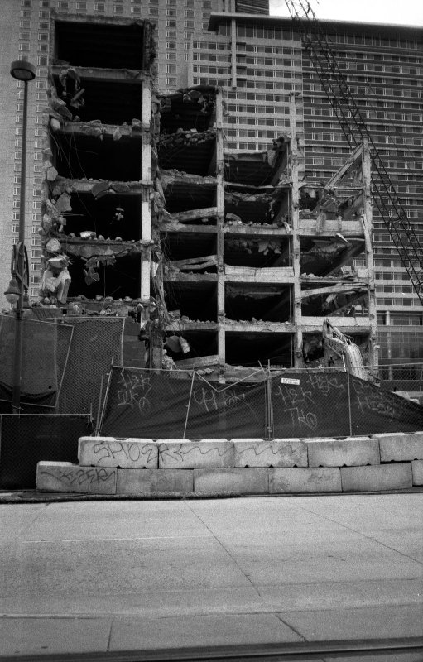
Figure 3: Ruined building
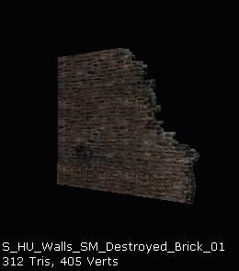
Figure 4: Destroyed brick wall static mesh
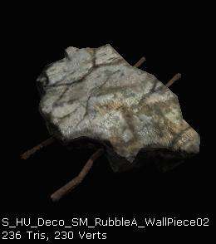
Figure 5: Broken Reinforced concrete
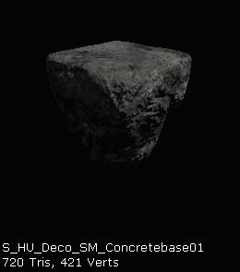
Figure 6: Broken concrete
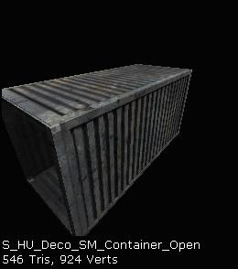
Figure 7: Metal cargo container
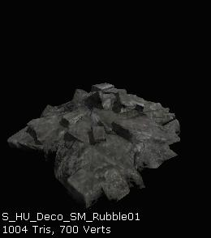
Figure 8: Standing rubble pile
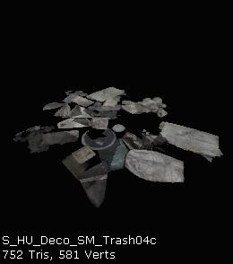
Figure 9: Human trash
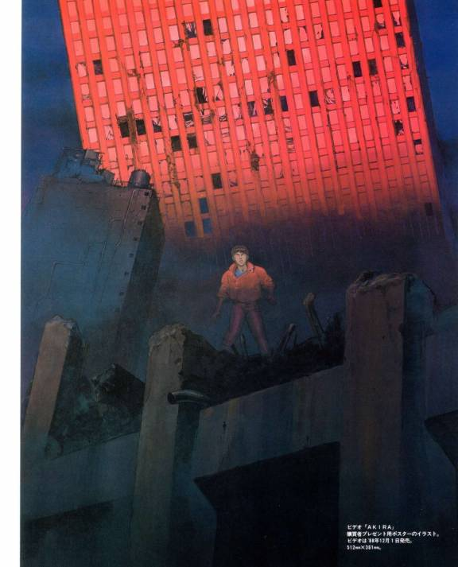
Figure 10: Ruined skyscraper
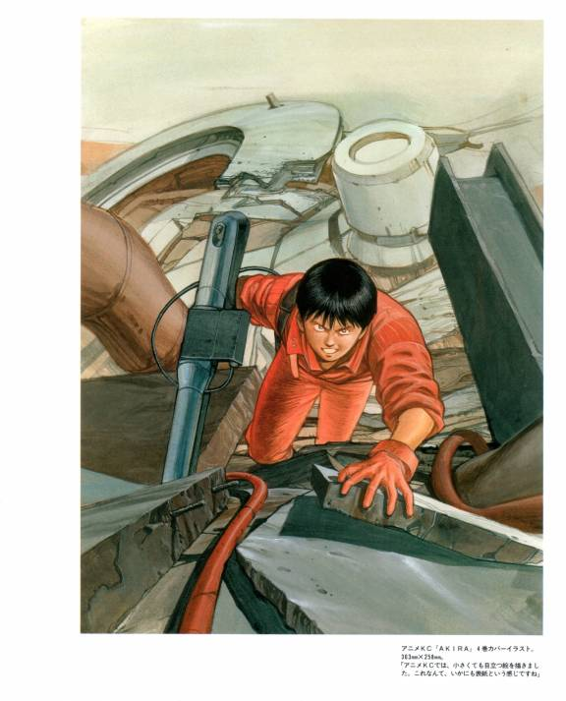
Figure 11: Concrete, building materials, junk

Models/Architecture
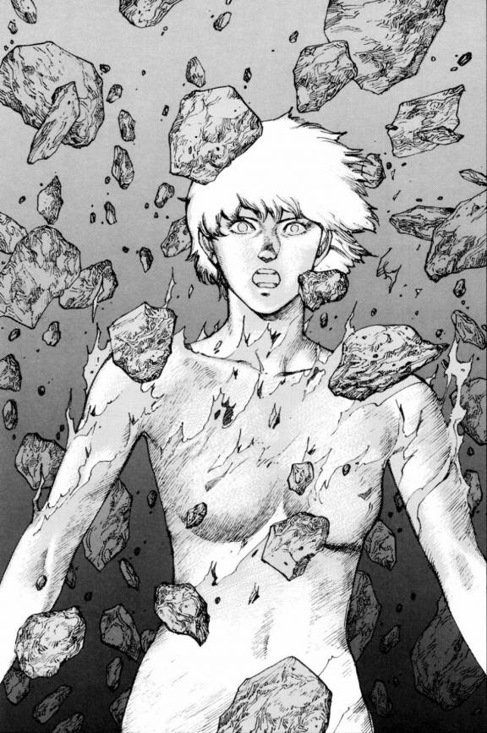
Figure 12: Floating concrete rubble
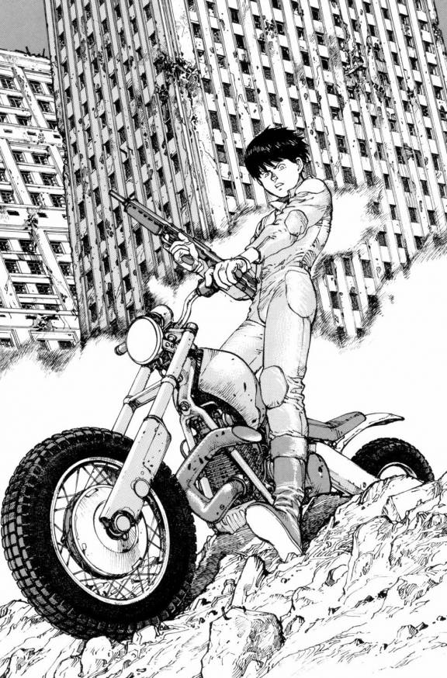
Figure 13: Ruined buildings, rubble

Textures/Lighting
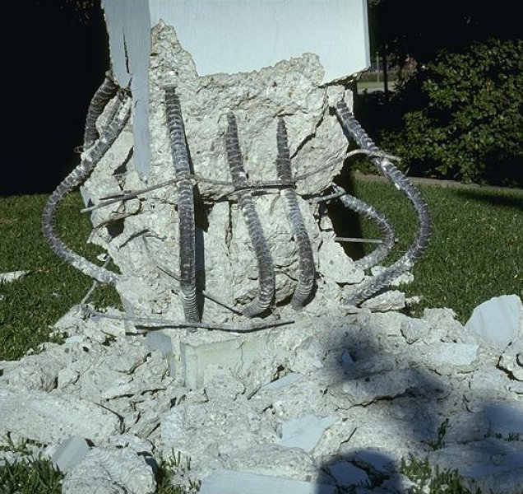
Figure 14: Broken reinforced concrete pillar
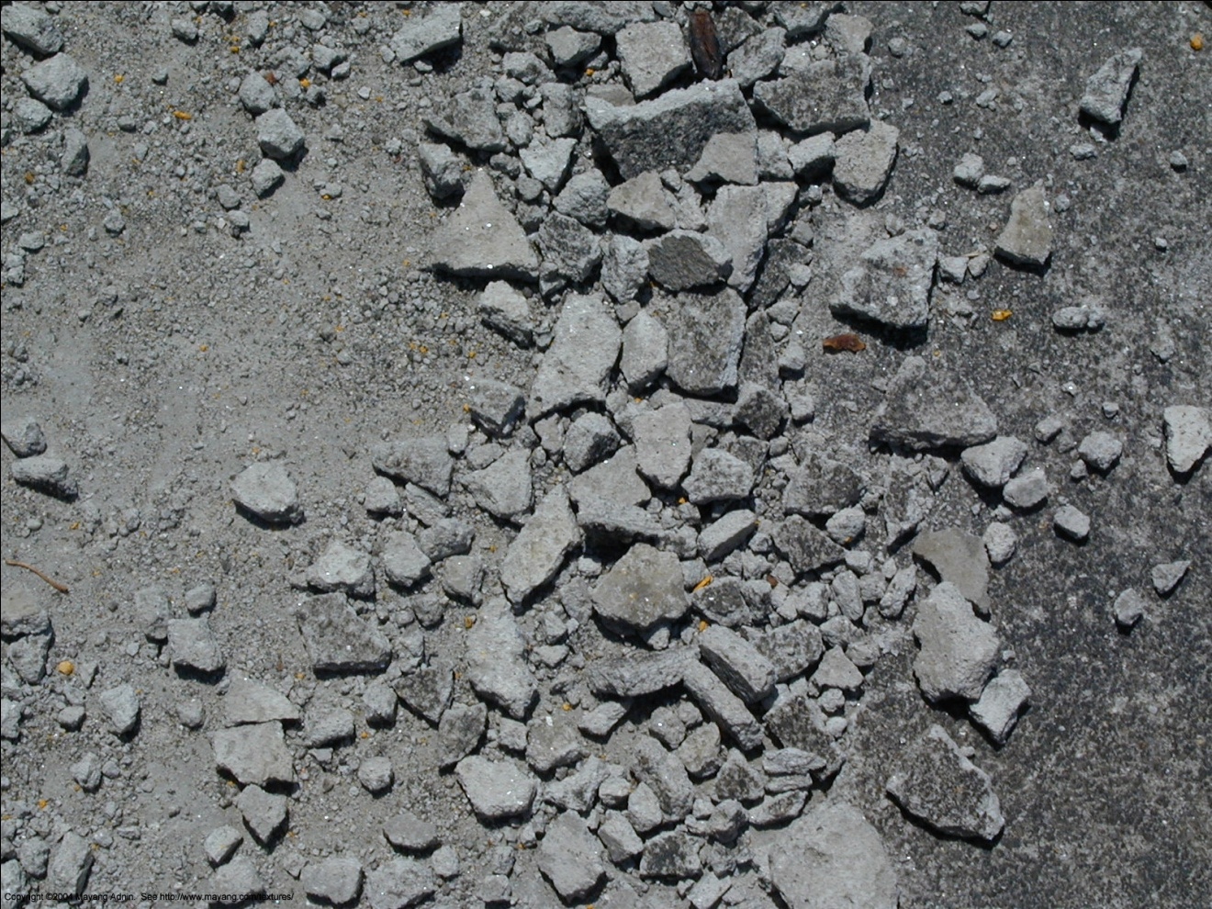
Figure 15: Broken concrete texture detail
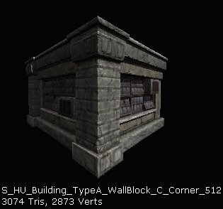
Figure 16: Human building corner
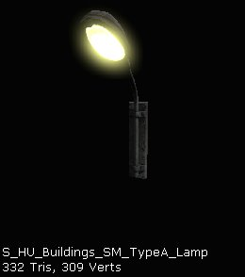
Figure 17: Human outdoor lamp

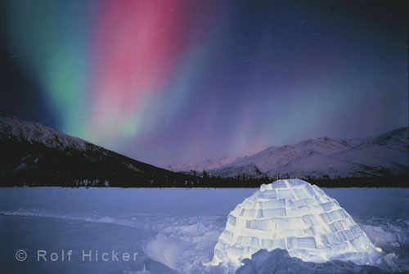
Figure 18: Aurora Borealis; the wormhole consists of multi-hued colors.

Characters/Vehicles

No additional characters or vehicles used on this map.

Maps

Legend
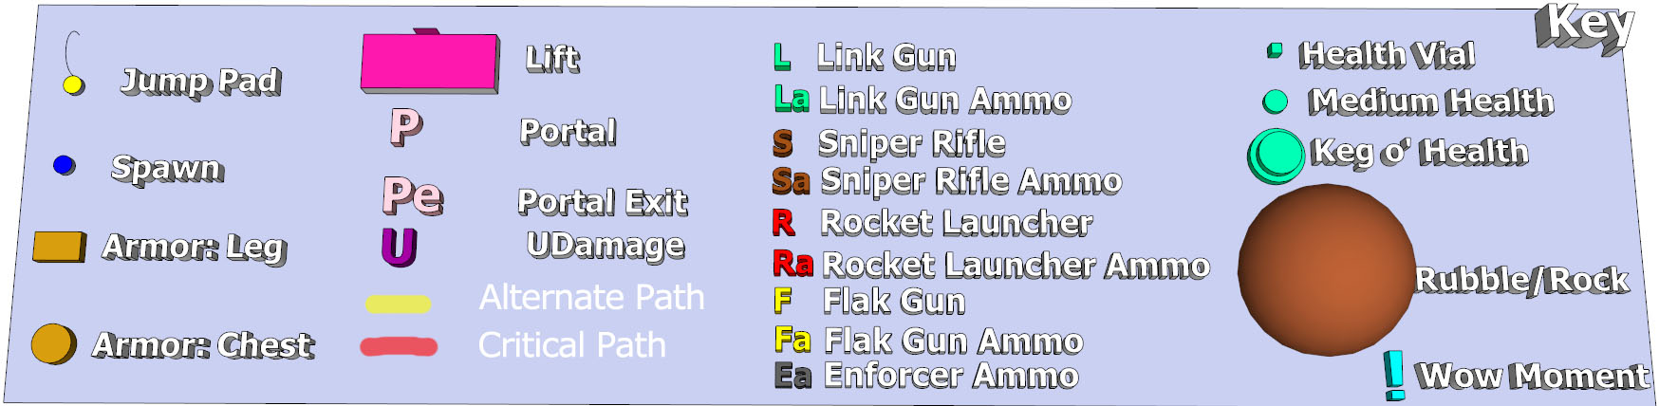
Figure 19: Key/Legend
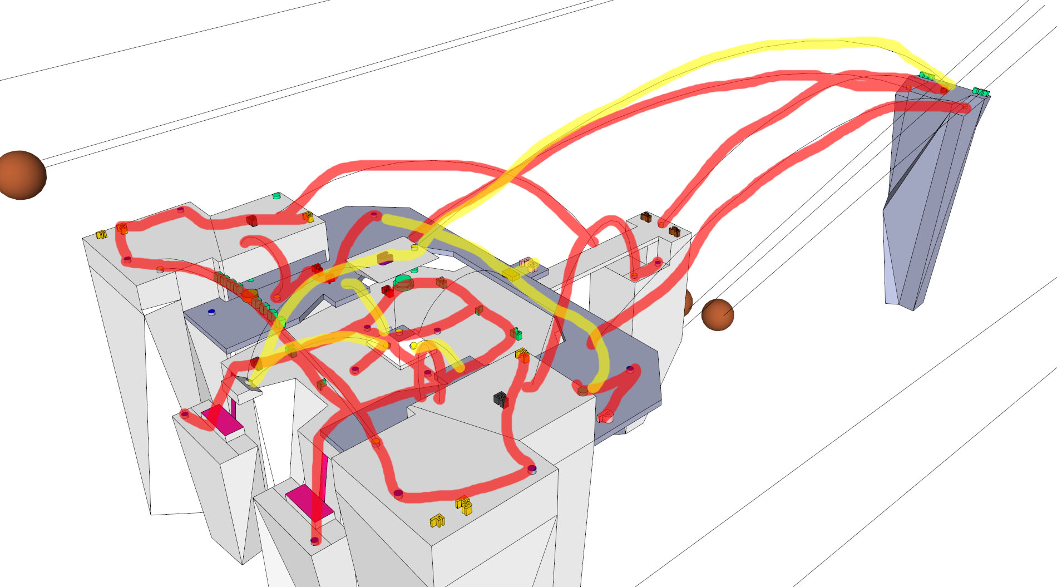
Figure 20: Overall Flow (details in Gameplay Overview section)

Figure 21: Overall Isometric View (First View)
Figure 22: Key/Legend
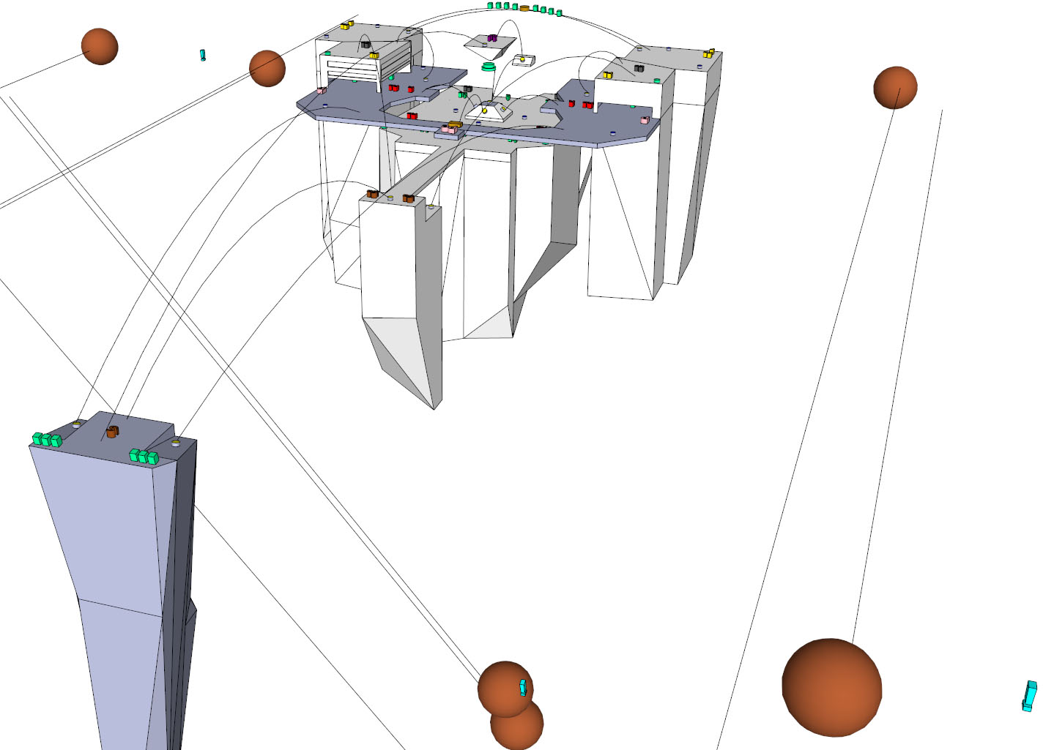
Figure 23: Overall Isometric View (Second View)
Figure 24: Key/Legend
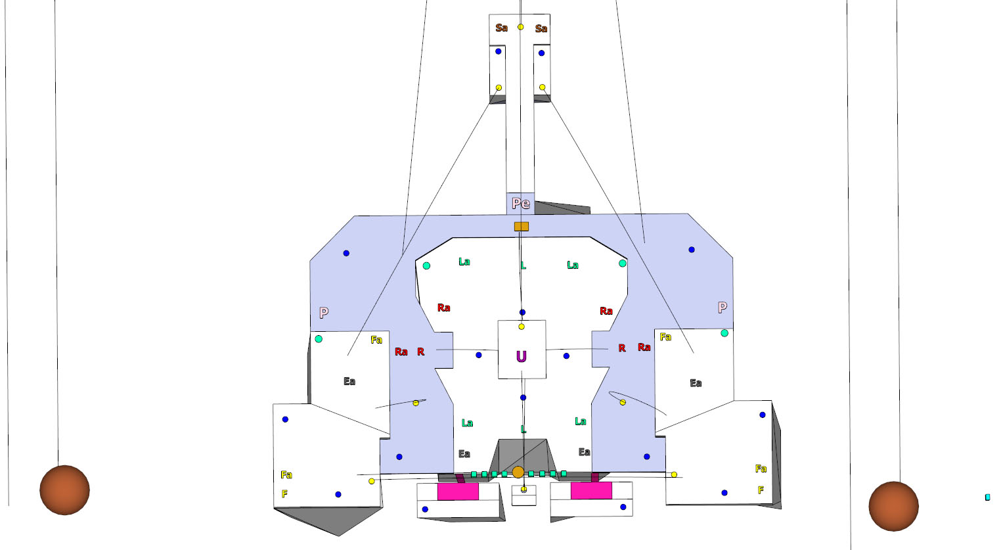
Figure 25: Overview of main map area (note floating rubble on either side)
Figure 26: Key/Legend
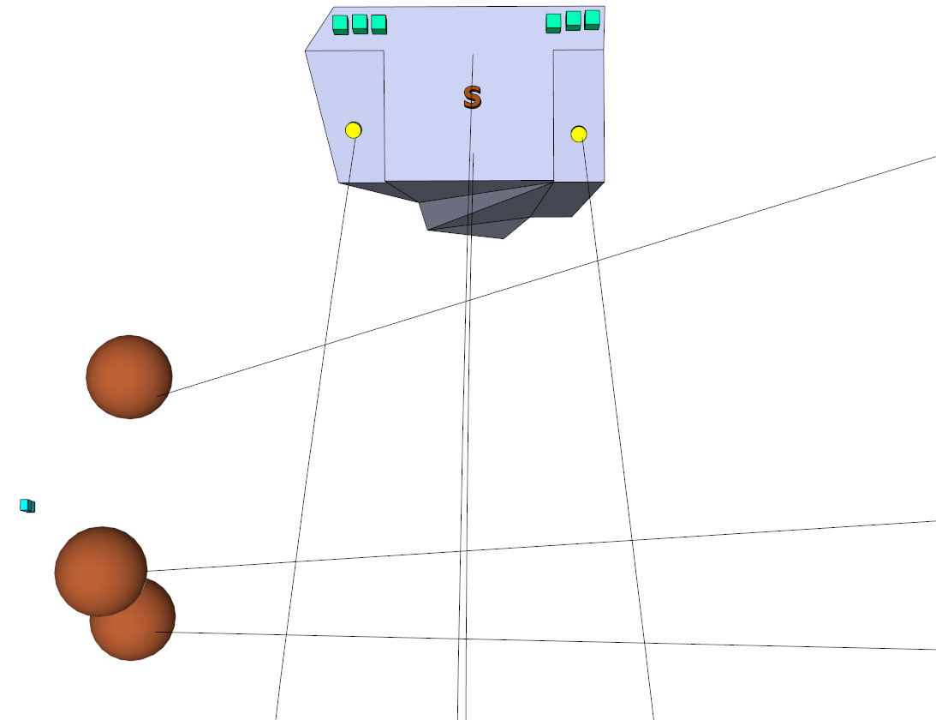
Figure 27: Overview of sniper roost (lower left indicates flying rubble obstacles)
Figure 28: Key/Legend
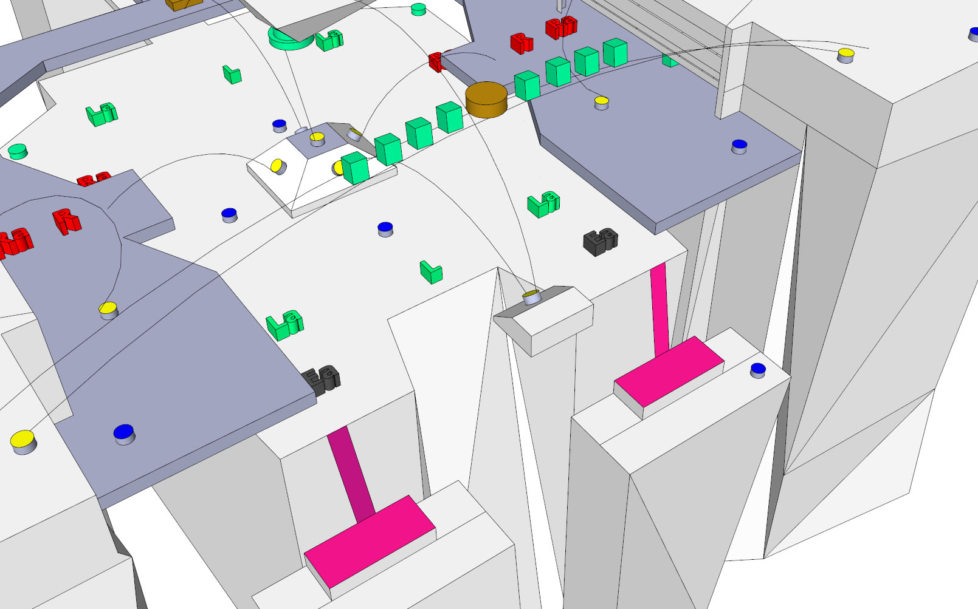
Figure 29: Rear Elevators and arcing jump pad detail (Elevators follow magenta path)
Figure 30: Key/Legend
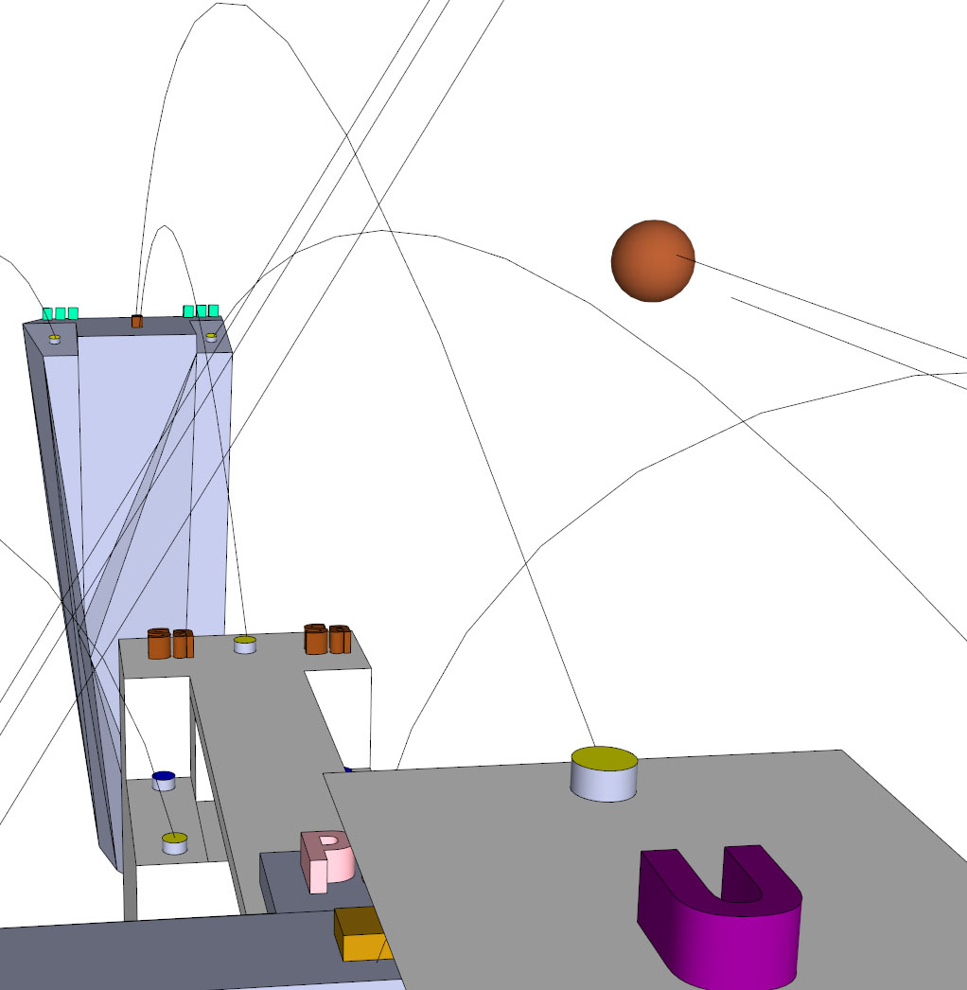
Figure 31: UDamage platform to Sniper roost jump pad (Arc has less chance of hitting flying debris, but players take damage)
Figure 32: Key/Legend

http://io9.com
http://webshots.com
Unreal Tournament 3
Ibid.
Unreal Tournament 3
Ibid.
Unreal Tournament 3
Ibid.
Katsuhiro Otomo, Akira
Katsuhiro Otomo, Akira
Katsuhiro Otomo, Akira
Katsuhiro Otomo, Akira
http://www.arch.virginia.edu/~km6e/tti/tti-summary/full/conc-col-comp.jpeg
http://mayang.com
Unreal Tournament 3
Unreal Tournament 3
Rolf Hicker

