**Smoke in the Sky**

**Gears of War**

***Document Date: April 7, 2010***

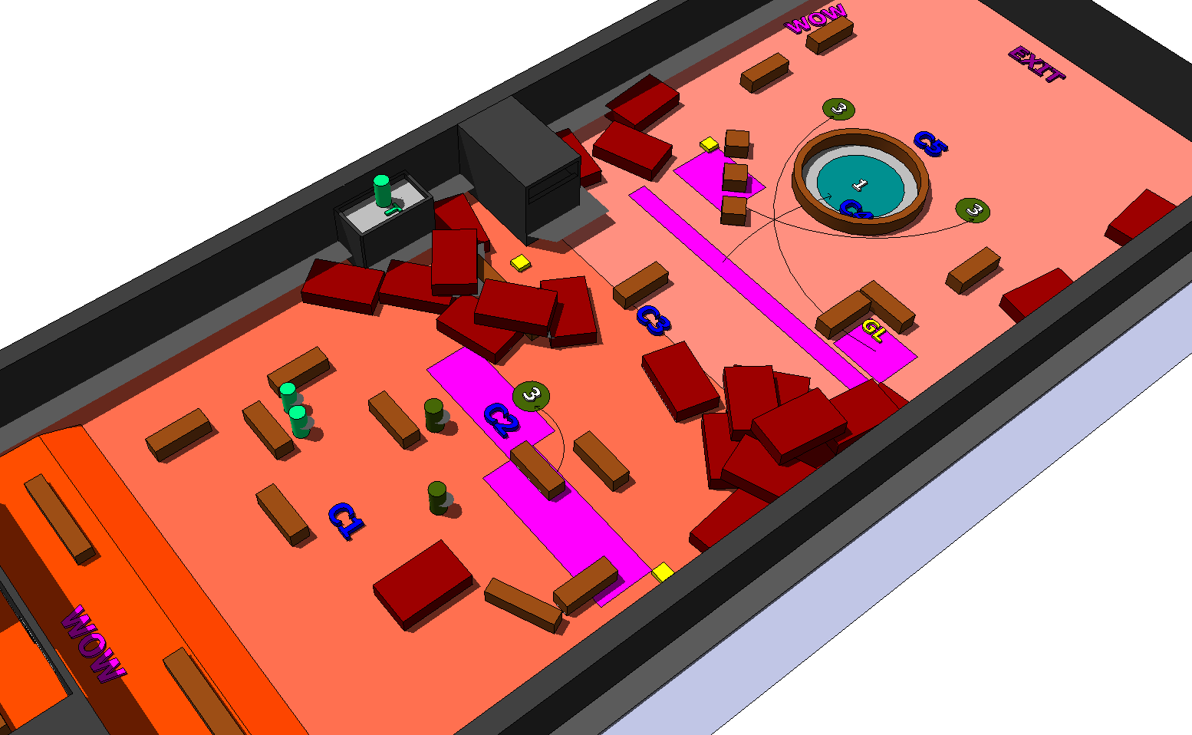

**Designer: Wade-Hahn Chan**

**Intended Level Delivery Date: May 13, 2010**

**Table of Contents**

Revision Notes 3

Quick Summary 4

Gameplay Overview 5

General Game Flow 6

Major Elements 11

Objective Summary 11

Technical Overview 11

Campaign 11

Mission Location 11

Mission Difficulty 12

Mission Metrics 12

Level Atmosphere/Mood 13

Story 13

Major Areas/Visual Themes 15

Area 1: Refinery Foyer 15

Area 2: Refinery Exterior 18

Map Objectives 25

Challenge Highlights 25

Water Cooler Moments 25

Actors 26

Player (Marcus Fenix) 26

Key Actors 27

Supporting Actors 27

Locust Drones 27

Locust Grenadiers 28

Boomer 29

Key Assets 30

User Interface 33

Gameplay Details 34

Gameplay Mechanics 34

Level Progression Chart 35

Map(s) 36

Key 36

Sketch(s) 37

Walkthrough/Detailed Map Description 39

Area 1.1 39

Area 1.2 40

Area 1.3 41

# Revision Notes

**04/07/10** – Initial version of document, as adapted from the Level Abstract

# Quick Summary

*Smoke in the Sky* consists of a single-player chapter within a three-part Act taking place in the *Gears of War* universe. Marcus Fenix must escape after sabotaging a Locust base of operations located inside of a recently lost COG industrial complex. After sealing the front interior of the base with explosives, Marcus must escape by sprinting across outdoor towards an escape aboard an incoming King Raven helicopter. However, Marcus must engage and mostly avoid Boomers, emplaced Troika machineguns and numerous Grenadier spawns. Midway in his retreat, Marcus calls down support fire from a King Raven Helicopter. Like all *Gears of War* maps, the gameplay revolves around third-person shooting. The map takes place between the events of *Gears of War* and *Gears of War 2*.

# Gameplay Overview

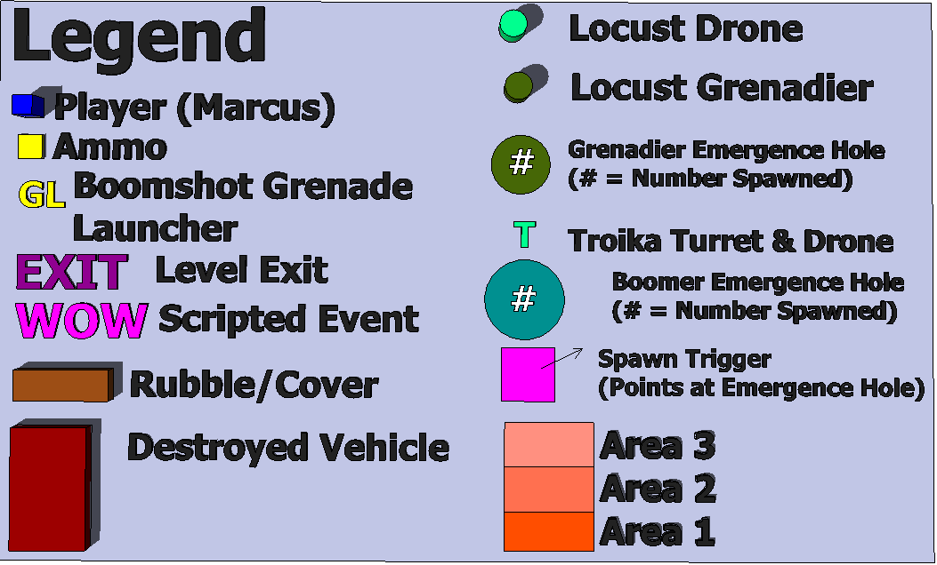The light blue lines indicate the critical path.



Darker blue lines indicate branching paths.

#### General Game Flow

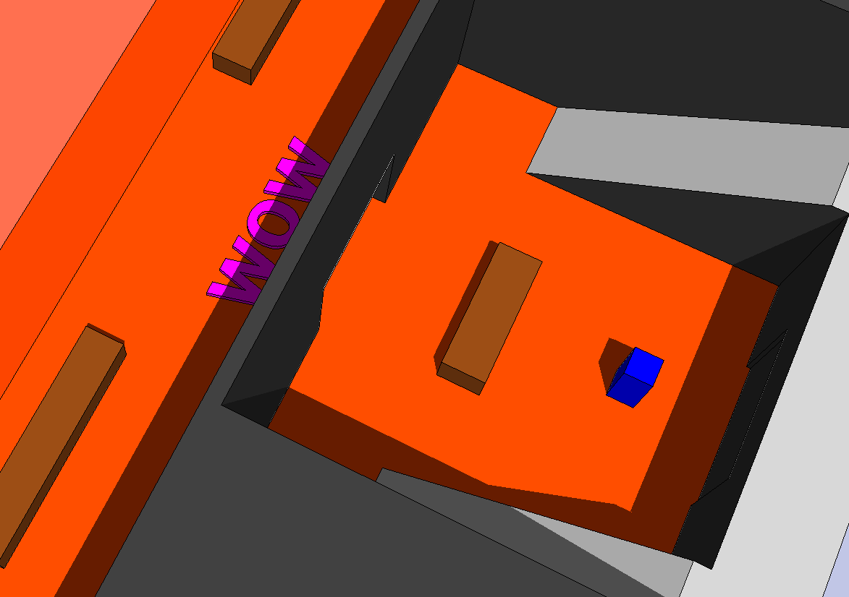

*Smoke in the Sky* begins with Marcus in the foyer of the Imulsion refinery. He exits the foyer and triggers a blast that seals the front door of the complex.

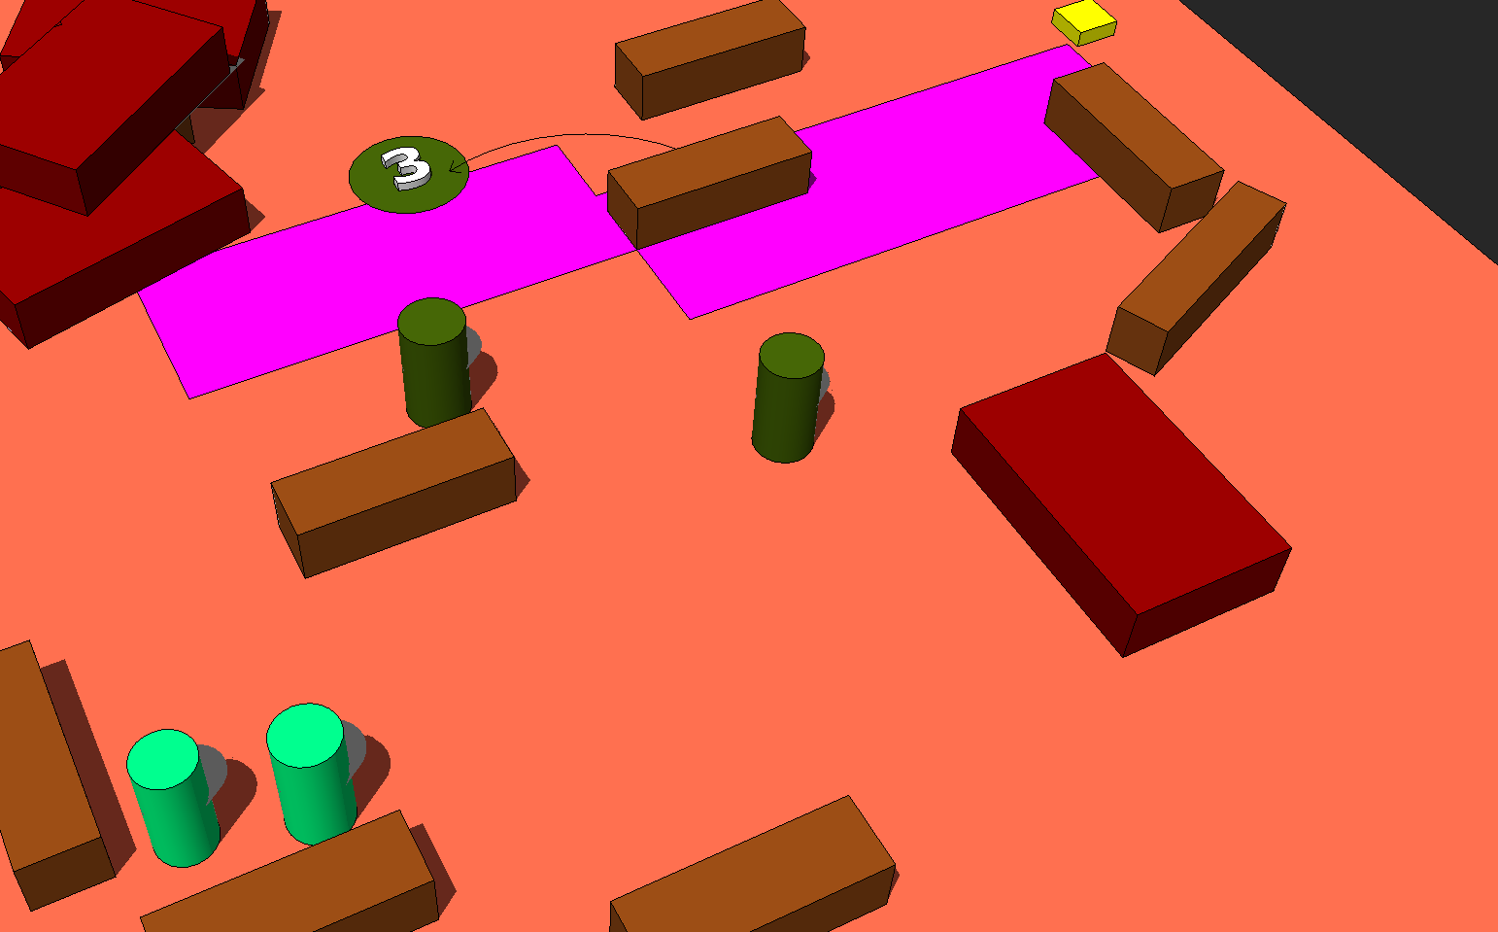

The blast draws the ire of a squad of two Drones and two Grenadiers. After dispatching the squad, Marcus chooses to power through the area or flank to the right where he finds an ammunition pack. After moving forward, an emergence hole appears, sending out another squad of three Grenadiers who engage Marcus.

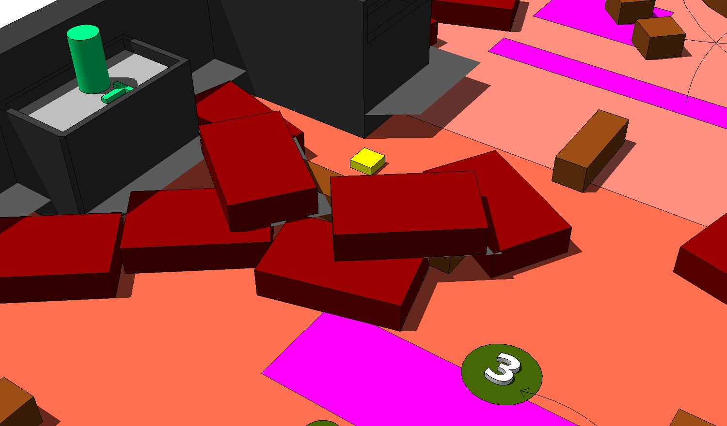

He dodges fire from an emplaced Troika turret from the left and pushes forward, throwing a bolo grenade into a Grenadier emergence hole.

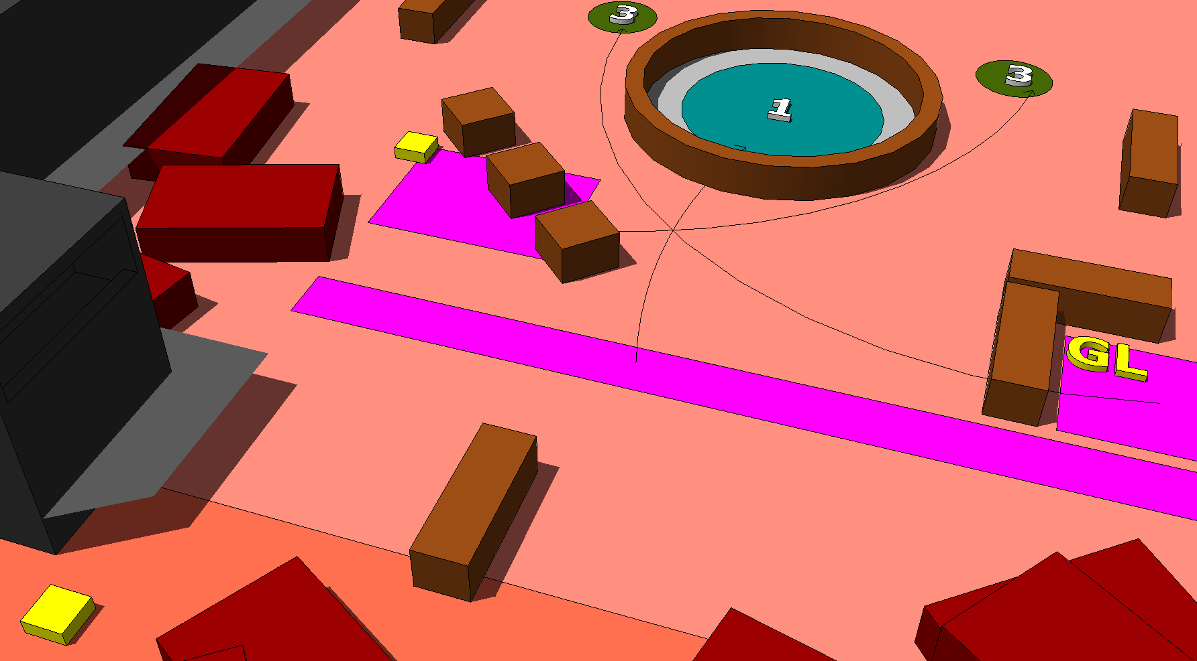

Marcus then pauses to grab ammo, and then moves forward through a pile of burning cars before seeing a round fountain ahead. The fountain falls into a gigantic emergence hole and a Boomer crawls out of the hole. One (of the two) more emergence hole falls away behind the fountain and three grenadiers begin to emerge one at a time.

Marcus spots a Boomshot Grenade Launcher to the right and ammo with more cover to the left.

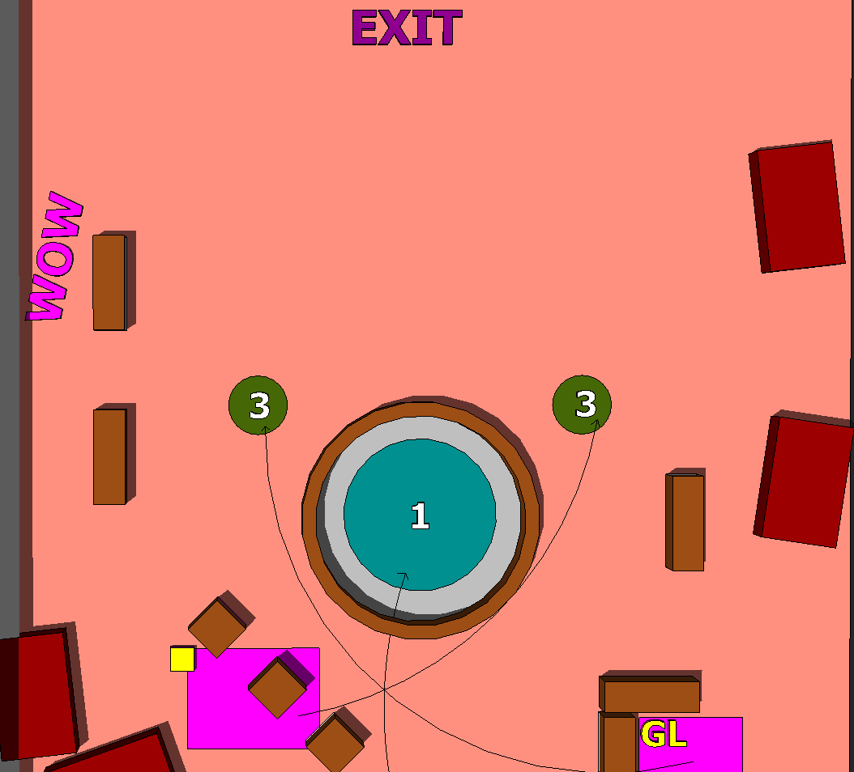

Marcus sprints to the left, dodging rocket fire, and finds a radio on the ground. He calls for support from a COG King Raven Helicopter.

A King Raven strafes the entirety of the outside area, killing the Boomer and the Grenadiers.

Marcus then runs dust-off zone and the King Raven touches down to carry him away.

#### Major Elements

* Provides players a manic escape from danger
* Encourages players to dodge enemies rather than directly engage them.
* Wow moments:
  + Machinima cinematic showing an explosion of the refinery at the beginning of the level.
  + Triggering a King Raven Helicopter to swoop in and clear enemy positions with gunfire
  + Outro machinima cinematic showing Marcus jump on to a King Raven Helicopter and escaping.

#### Objective Summary

* Avoid dying from enemy fire.
* The player must guide Marcus through the exterior to the base to escape on a King Raven Helicopter.

# Technical Overview

#### Campaign

* *Smoke in the Sky* takes place between the events of *Gears of War* and *Gears of War 2*. The setting is located at an industrial Imulsion refinery several miles away from Jacinto City.
* This level takes place after two previous chapters in a three-part Act.
  + In the prior Acts, Marcus infiltrates a raided COG Imulsion refinery. The COG wants Marcus to scout out the Locust threat to assess if the plant is salvageable. However, Marcus finds that the Locust turned the building into a major base of operations and he decides to destroy the building’s entrances before escaping on a King Raven Helicopter, which helps him by strafing enemy positions.

#### Mission Location

* Theme: *Smoke in the Sky*’s theme is about escape, in this case from direct danger of Locust troops.
* Mood: Harried desperation, as the player attempts to escape the Locust threat.
* Setting: In and around a recently raided COG Imulsion refinery
* Time: Late day/dusk
* Season: Autumn. The sun casts a wan, brownish tint across the landscape
* Weather: Sunny, but smoke and flames obstruct much of the sky

#### Mission Difficulty

* Difficulty:
  + Beginning: ~1 (scale of 1-5). The first leg of *Smoke in the Sky* contains no enemies to fight. The player simply needs to walk outside of the foyer of the Imulsion Refinery.
  + Middle: ~3 (scale of 1-5). The middle level contains enough enemies and dangers to overwhelm players, including squads of Grenadiers covered by a Troika.
  + End: ~4 (scale of 1-5). The final part of the level contains explosive dangers and enough enemies that players should avoid a head-to-head fight.

#### Mission Metrics

* Play Time: ~15 minutes
* Physical Length (in Unreal Units): 3072 Width x 5632 Length x 1536 Height
* Max New Characters: 1.
  + Marcus Fenix, main player character
  + A variety of enemies, including eleven Grenadiers, two Drones, one Troika Heavy Machine Gun turret manned by a Drone and one Boomer
* Max Visual Themes: 2.
  + A foyer of an industrial building at the start of the level
  + One stretch of outdoor terrain covered with rubble, coated in dust and surrounded by concrete walls and rocky hills. Burning vehicles and craters cover the outdoor area.Technical Details

#### Level Atmosphere/Mood

The first chapter in this mini-Act provided players with small-scale, skirmish-style combat. However, the opening of *Smoke in the Sky* —an explosion in a building—sets a harried, desperate tone for the rest of the chapter, akin to an escape.

* The level begins with an explosion over the building the player first leaves. The player feels the only direction to move is forward.
* Burning cars cover the exterior area. Black smoke covers the sky.
* The pacing of the level offers players only brief pauses in the action, indicating that the player must stick to cover and move quickly to survive.

#### Story

* Intro: After scouting out the COG Imulsion facility, Marcus Fenix realizes that the Locust forces quickly established the refinery as a major above ground operations platform. Realizing that the COG lost the facility completely, Marcus opts to sabotage it by blowing up parts of the facility in succession.
* In-Game:
  + *Smoke in the Sky* begins with Marcus in the foyer of the Imulsion refinery.
  + He exits the foyer and triggers a blast that seals the front door of the complex. The blast draws the ire of a squad of Locust Drones and Grenadiers.
  + After dispatching the squad, the Locust forces engage Marcus in earnest amidst the debris and rubble of the facility entrance.
  + He dodges fire from an emplaced Troika turret from the left and pushes forward, throwing a bolo grenade into a Grenadier emergence hole.
  + Marcus then pauses to grab ammo, and then moves forward through a pile of burning cars before seeing a round fountain ahead.
  + The fountain falls into a gigantic emergence hole and a Boomer crawls out of the hole. Two more emergence holes fall away behind the fountain and six grenadiers begin to emerge one at a time.
  + Marcus sprints to the left, dodging rocket fire, and finds a radio on the ground. He calls for support from a COG King Raven Helicopter.
  + A King Raven strafes the entirety of the outside area, killing the Boomer and the Grenadiers.
  + Marcus then runs dust-off zone.
* Outro: After jumping on the helicopter, Marcus narrowly escapes death as the King Raven lifts him away towards safety.

#### Major Areas/Visual Themes

###### Area 1: Refinery Foyer

* Area 1 consists of the foyer of a former COG refinery, taken by Locust troops.
* Visual References
  + Terrain/Vegetation
    - 
    - Figure : Stone stairs[1]
    - 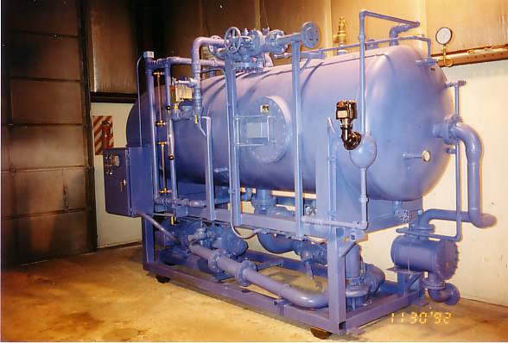
    - Figure : Industrial Boiler[2]
  + Models/Architecture
    - 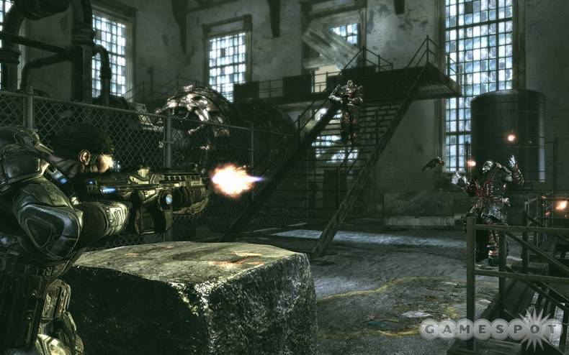
    - Figure : Industrial base interior[3]
  + Textures/Lighting
    - 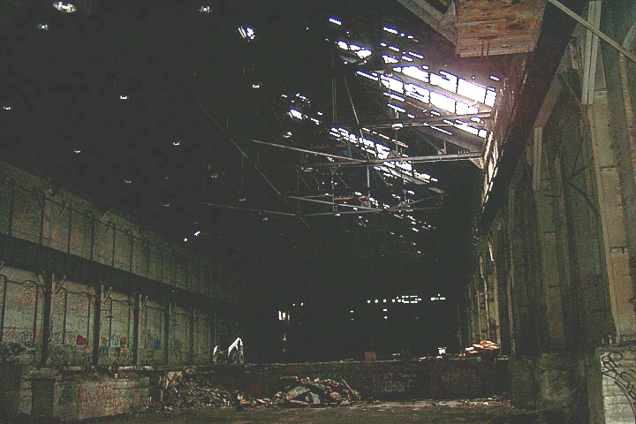
      * Figure : Example lightless warehouse interior, lit mostly by skylights/holes in the ceiling[4]
    - 
    - Figure : Concrete texture[5]
  + Characters/Vehicles
    - None

###### Area 2: Refinery Exterior

* Area 2 depicts the immediate exterior of the COG imulsion refinery, littered with burning cars, shot up buildings and Locust troops.
* Visual References
  + Terrain/Vegetation
    - 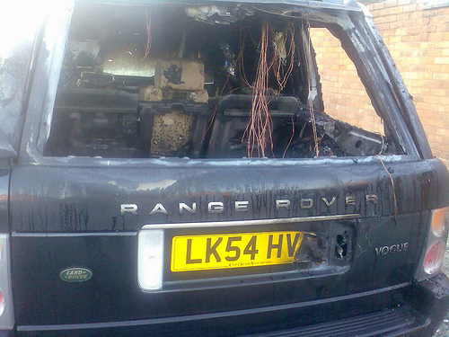
    - Figure : Burnt out Car[6]
    - 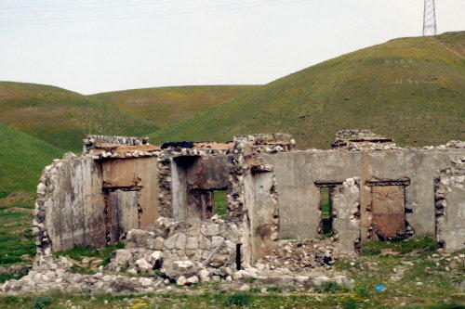
    - Figure : War-blasted rubble[7]
  + Models/Architecture
    - 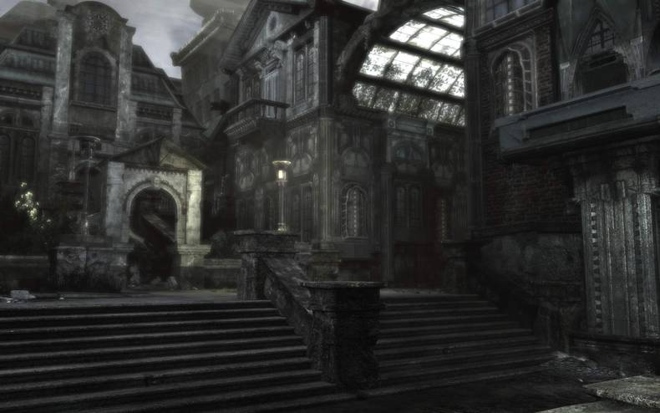
    - Figure : Front Entrance of industrial base[8]
    - 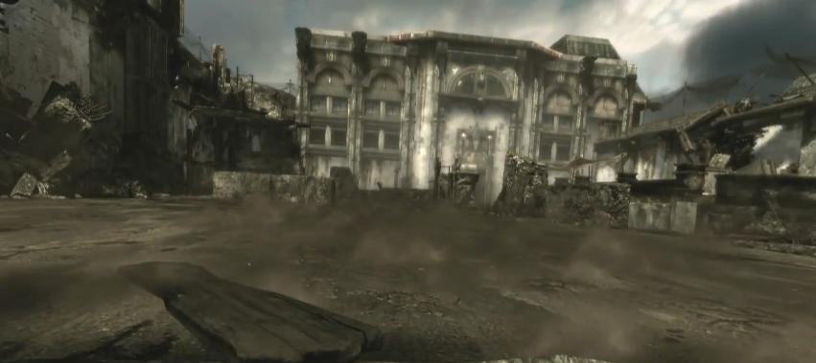
      * Figure : industrial base exterior ground leading to helicopter liftoff[9]
  + Textures/Lighting
    - 
      * Figure : Smokey, hazy sky with dusk sunlight peering through[10]
    - 
    - Figure : Dirty asphalt texture[11]
    - 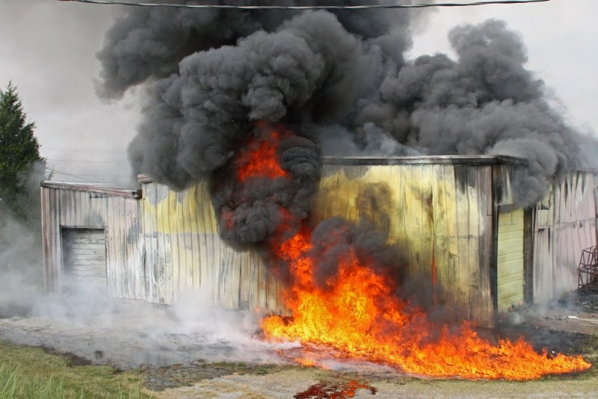
    - Figure : Smoke and flames[12]
  + Characters/Vehicles
    - 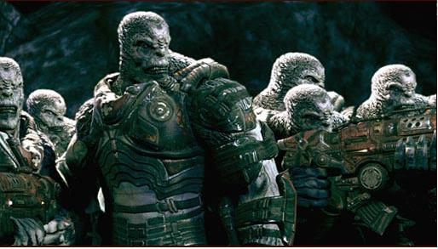
      * Figure : Locust Drones[13]
    - 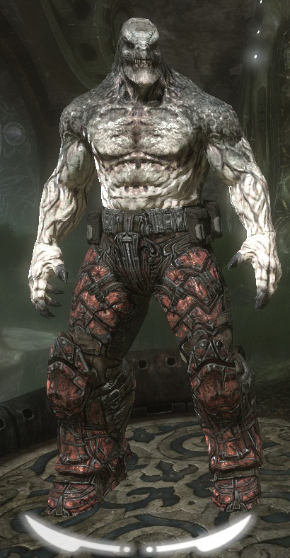
      * Figure : Locust Grenadier[14]
    - 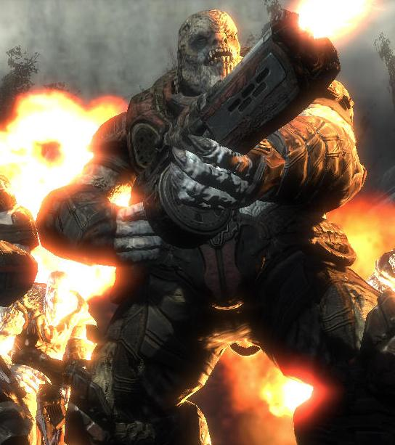
      * Figure : Locust Boomer[15]

#### Map Objectives

* Primary
  + Escape the level
* Secondary
  + Clear level of enemies
* Bonus
  + Clear level of enemies by using a King Raven flyover
* Hidden
  + None

#### Challenge Highlights

* Combat
  + The level includes 5 combat challenges, as shown on the overall map:
    - Challenge 1: Basic single front, single flank fight against two Drones and two Grenadiers
    - Challenge 2: Close-ranged emergence hole spawn containing three Grenadiers
    - Challenge 3: Troika Heavy Turret at a heightened location requiring the player to traverse heavy cover to avoid or destroy
    - Challenge 4: Emergence hole that spawns a boomer at mid-to-long range to the player
    - Challenge 5: One of two emergence holes spawn three Grenadiers (the location of the emergence hole depends on which direction the player takes)
* Stealth
  + None
* Puzzles
  + None
* Conversation
  + None
* Boss Battles
  + None

#### Water Cooler Moments

* After exiting Area 1, a machinima plays depicting an explosion above the refinery as Marcus exists, spewing smoke into the sky.
* If choosing the left hand direction in Area 3, the player calls a King Raven helicopter to perform a strafing run over the area

#### Actors

##### Player (Marcus Fenix)

* Model:
  + 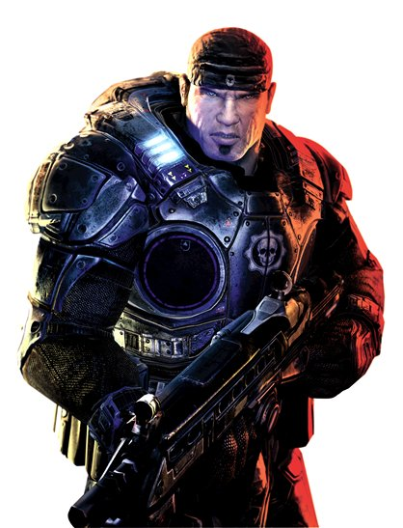
* Figure : Marcus Fenix[16]
* Inventory:
  + Lancer Assault Rifle
  + Gnasher Shotgun
  + Boltok Pistol
  + Bolo Grenades
  + Full ammunition for all weapons
* Start Location
  + Inside Area 1, the foyer of an Imulsion Refinery
* Motives/Objectives
  + To escape the area of the refinery by way of a waiting King Raven

##### Key Actors

No key actors contained within level

##### Supporting Actors

###### Locust Drones

* Models:
  + 
* Figure : Locust Drones[17]
* Inventory:
  + Hammerburst Assault Rifle
* Motives/Objectives
  + Kill player through medium-range support fire and some close combat
* Uses Within Level: 3, one behind Troika Machine Gun Turret

###### Locust Grenadiers

* Model:
  + 
* Figure : Locust Grenadier[18]
* Inventory:
  + Gnasher Shotgun, Bolo Grenades
* Motives/Objectives
  + Kill player through aggressive tactics and direct combat
* Uses Within Level: 11

###### Boomer

* Model:
  + 
* Figure : Locust Boomer[19]
* Inventory:
  + Gnasher Shotgun, Bolo Grenades
* Motives/Objectives
  + Kill player through aggressive tactics and direct combat
* Uses Within Level: 11

#### Key Assets

* Weapons/Ammo
  + 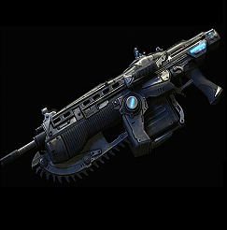
    - Figure : Lancer Assault Rifle[20]
  + 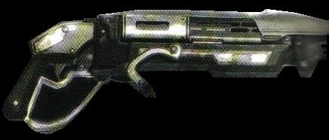
    - Figure : Gnasher Shotgun[21]
  + 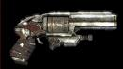
    - Figure : Boltok Pistol[22]
  + 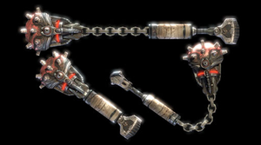
    - Figure : Bolo Grenades[23]
  + 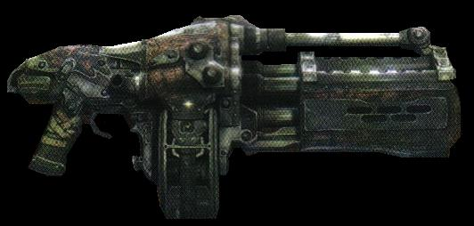
    - Figure : Boomshot Grenade Launcher[24]
  + 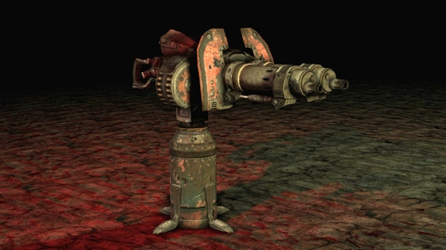
    - Figure : Troika Heavy Turret[25]
  + 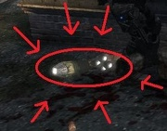
    - Figure : Ammunition/Ammo Crates[26]
* Vehicles
  + 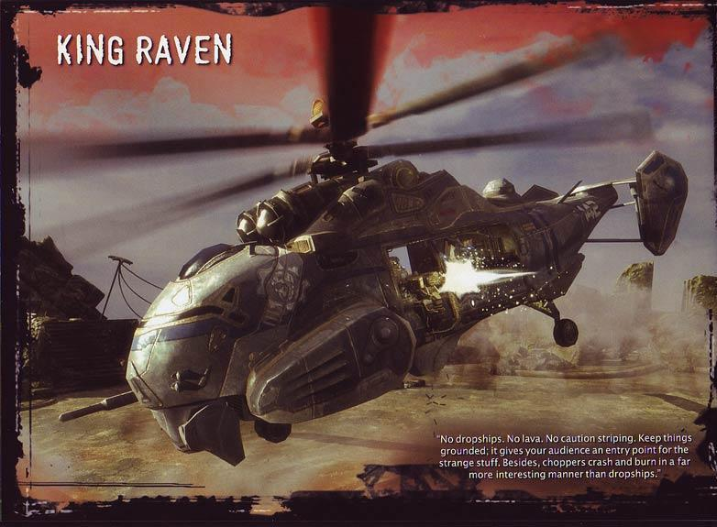
    - Figure : King Raven Helicopter[27]
* Interactive Elements
  + None.

#### User Interface

* Pre-Game Information
  + None
* In-Game Information
  + None
* Post Game Information
  + None
  + Stats
* HUD Elements
  + Normal Elements Used:
    - Crosshair
    - Health indicators (red overlay)
    - Weapon selection and ammo count
  + Special Elements Required: None

# Gameplay Details

#### Gameplay Mechanics

* Prerequisite skills:
  + Basic *Gears of War* movement and shooting:
    - Movement:
      * Running
      * Sprinting
      * Diving
      * Cover mechanics
        + Jumping cover to cover
        + Jumping out of cover
        + Jumping over cover
    - Shooting:
      * Hip shooting
      * Aimed shooting
      * In-cover shooting
      * Blind fire shooting
* Learned skills:
  + - None

#### Level Progression Chart

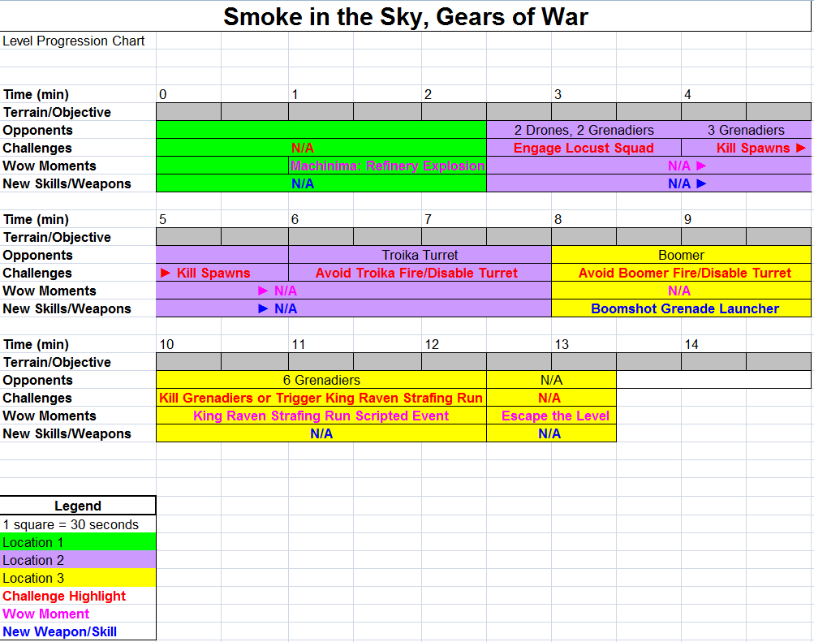

#### Map(s)

##### Key

##### 

##### Sketches

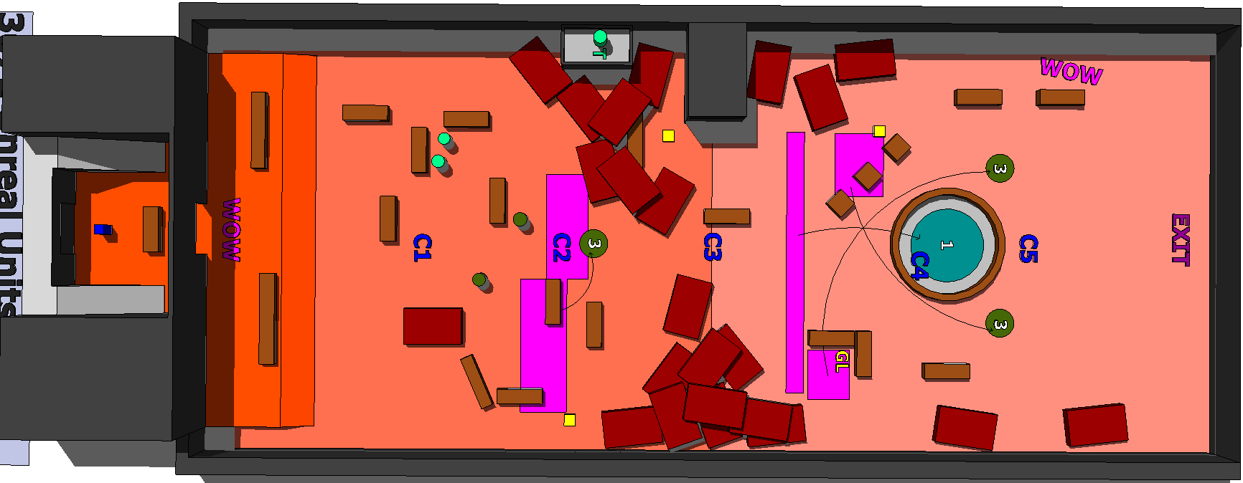

Figure : Overall overview of map

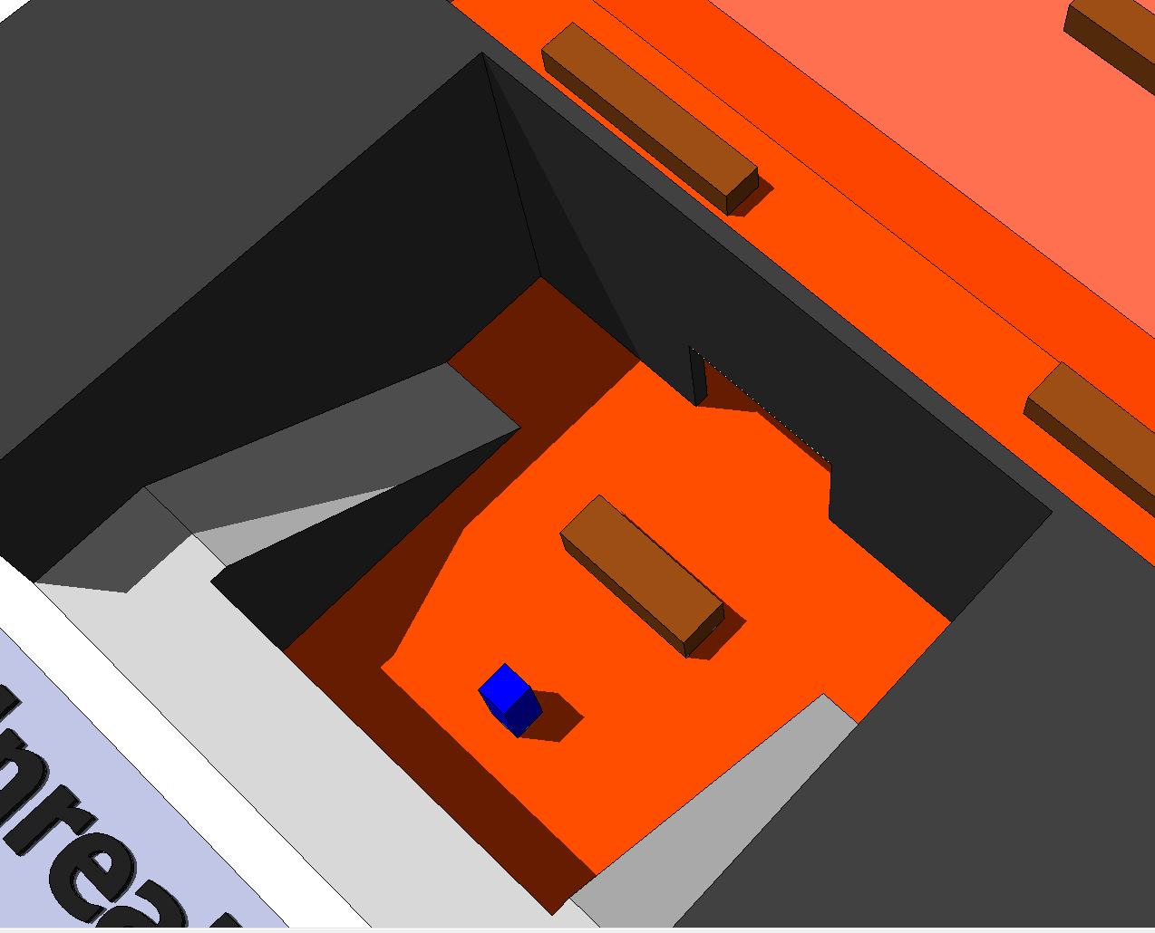

Figure : Interior overview



Figure : Exterior overview

#### Walkthrough/Detailed Map Description

##### Area 1.1

* Gameplay
  + Area 1.1 contains no action elements. The player simply needs to exit the building to trigger a machinima, which then seals player access to the area.
* Dialog
  + None
* Visual References
  + 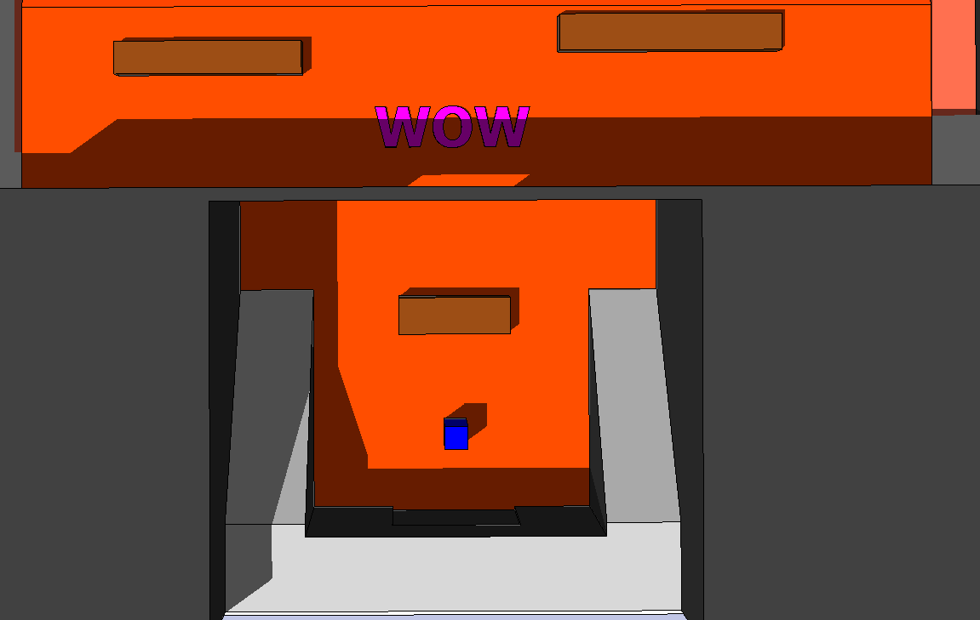

##### Area 1.2

* Gameplay
  + Area 1.2 starts with Challenge 1, where the player moving into cover to engage a squad of two Drones and two Grenadiers.
    - If the player chooses to move to the left and directly engage the squad in close combat.
    - Moving to the right gives the player ample cover and a longer range to work with.
  + At Challenge 2, an emergence hole falls away to reveal 3
  + At Challenge 3, the player must move through cover to avoid gunfire from a Troika turret.
    - The player either avoids the fire completely or destroys the turret by moving to the left, hugging cars through cover to clear the turret nest at mid-range.
* Dialog
  + None
* Visual References
  + 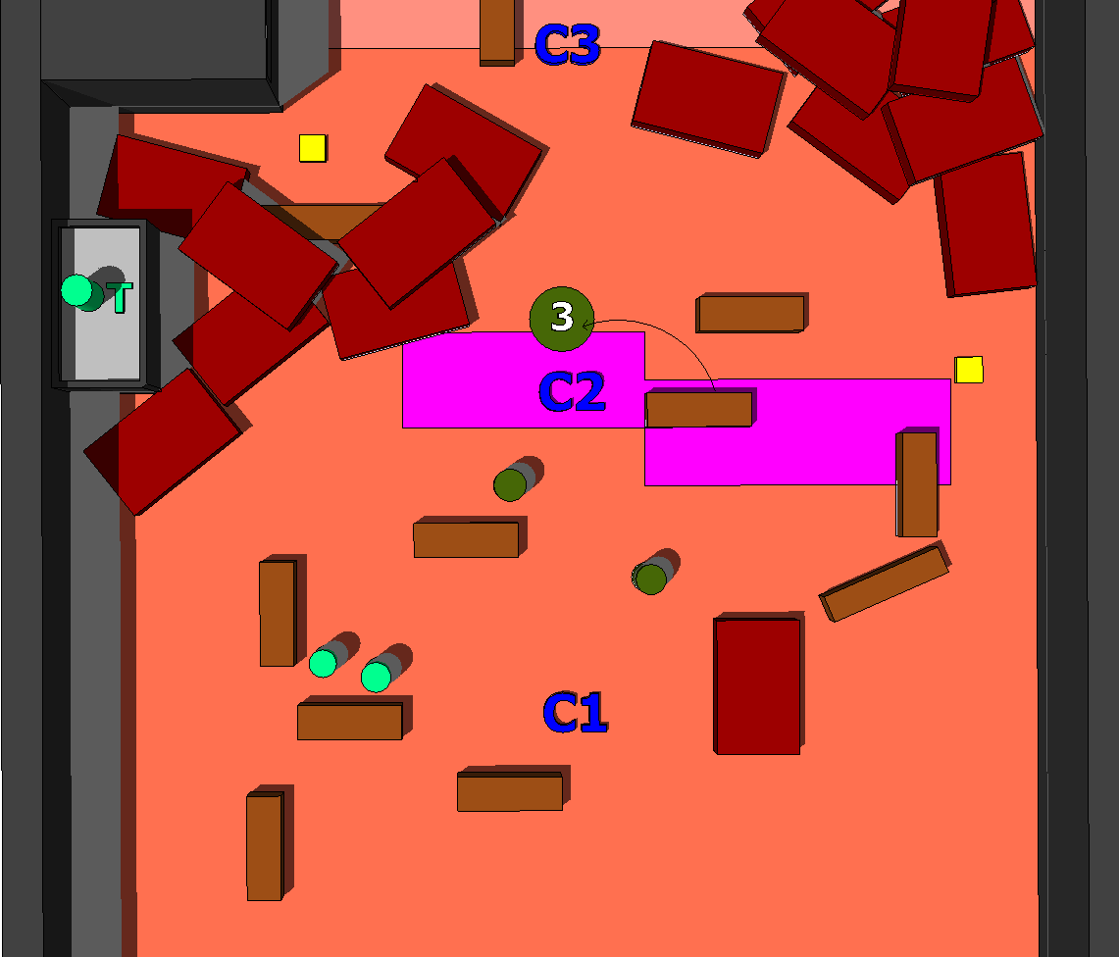

##### Area 1.3

* Gameplay
  + After Area 1.2, the player almost immediately encounters a boomer from an emergence hole in the middle of a fountain, indicated by Challenge point 4. The hole appears outside of grenade throwing distance.
  + Moving forward, the player also encounters one of two flanking Grenadier spawns, depending on the direction the player chooses.
    - If he moves to the right, the player picks up a Boomshot Grenade Launcher to help dispatch the enemies.
    - If he moves to the left, the player triggers a water cooler moment as a King Raven helicopter clears the area of enemies.
* Dialog
  + None
* Visual References
  + 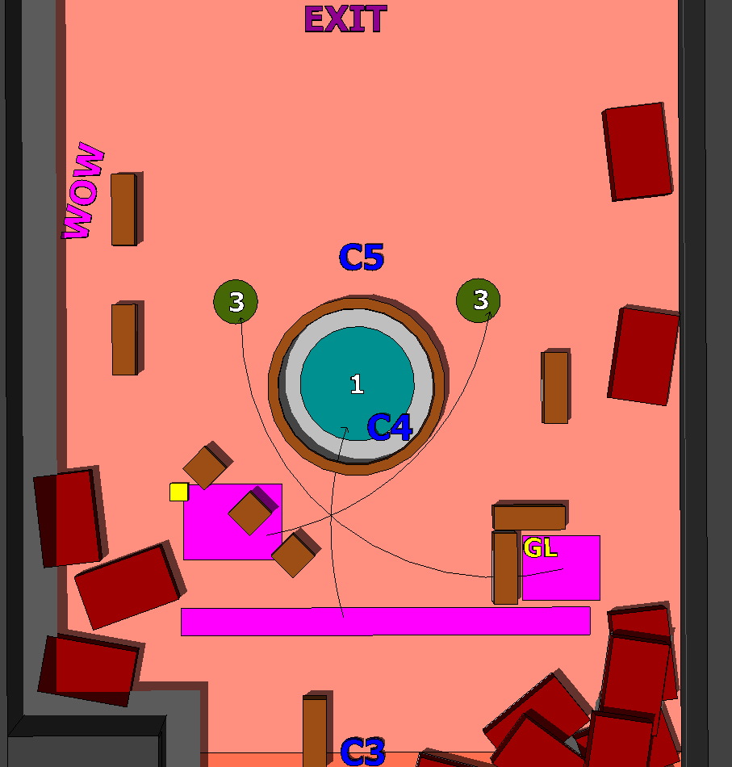

1. <http://www.umagc.com/>
2. http://www.diarionuevonorte.com
3. http://gamespot.com
4. https://www.acsa-arch.org
5. http://amazingtextures.com
6. http://johnhemming.blogspot.com
7. http://www.michaeltotten.com
8. http://gamespot.com
9. http://gearsofwar.wikia.com
10. http://www.istockphoto.com
11. http://freestocktextures.com
12. John Larew, http://nc911.com
13. http://gearsofwar.wikia.com
14. http://gearsofwar.wikia.com
15. http://gearsofwar.wikia.com
16. http://gearsofwar.wikia.com
17. http://gearsofwar.wikia.com
18. http://gearsofwar.wikia.com
19. http://gearsofwar.wikia.com
20. http://gearsofwar.wikia.com
21. Ibid.
22. Ibid.
23. http://gearsofwar.wikia.com
24. Ibid.
25. Ibid.
26. http://gearsofwar.wikia.com
27. http://gearsofwar.wikia.com